Entry 3 and Level 1
ASSESSMENTS

for

IMIAL Level 1 Award in Vehicle Maintenance (QCF)
OFQUAL I.D: 501/0550/4

IMIAL Level 1 Certificate in Vehicle Maintenance (QCF)
OFQUAL I.D: 501/0547/4

IMIAL Level 1 Diploma in Vehicle Maintenance (QCF)
OFQUAL I.D: 501/0732/X

Note: This document must be used in conjunction with the Qualification Guidance and Assessment Criteria and Assessment Support Pack

IMIAL Qualifications in Vehicle Maintenance
(Level 1) (QCF)

ASSESSMENTS

CONTENTS PAGE NO

L101 Health and Safety Practices in Vehicle Maintenance 3
L102 Tools Equipment and Materials for Vehicle Maintenance 5
L103 SI Engine Systems, Components and Operation 7
L104 CI Engine Systems, Components and Operation 10
L105 Engine Liquid Cooling & Lubrication Systems Components and Operation 13
L106 Steering and Suspension Systems Components and Maintenance (4 wheels or more) 18
L107 Vehicle Braking Systems Components and Maintenance 23
L108 Routine Vehicle Maintenance Processes & Procedures on Vehicles (4 wheels or more) 26
L109 Vehicle Wheels and Tyres Construction and Maintenance 28
L110 Vehicle Exhaust Systems, Components and Maintenance 31
L111 Vehicle Driveline Maintenance 34
L112 Spark Ignition System Maintenance 38
L113 Vehicle Electrical Foundation Skills 41
L114 Vehicle Lighting Systems Maintenance 45
L115 Routine Motorcycle Maintenance Processes and Procedures 48
L116 Motorcycle Steering and Suspension Systems Components and Maintenance 50
L117 Vehicle Body Repair Practices and Procedures 55
L118 Preparation Prior to Paint Refinishing 59
L119 Introduction to Spark Ignition Fuel Systems 62
L120 Introduction to Compression Ignition Fuel Systems 65
L121 Introduction to Low Carbon Technologies in the Automotive Industry 68
EL02 Introduction to the Retail Automotive Maintenance and Repair Industry 70
EL07 Principles of Component Fitting 73
EL12 Basic Vehicle Valeting 76
EL13 Light Vehicle Construction 79
EL14 Motorcycle Construction 82
EL16 Simple Paint Spraying and Procedures 85
Marking schemes 88

Assessors Guidance notes:

Where centre devised assessments are used or amendments are made to the suggested assessments, tutors must ensure that each assessment criteria is met and that any new/modified assessments are first agreed in writing with their external verifier.

LEARNER WORK SHEET

Unit No: L101
HEALTH AND SAFETY PRACTICES IN VEHICLE MAINTENANCE

Workshop Safety Inspection

Learner Name: |  |  |  | Date work carried out:
Assessment criteria covered: AC 1.2,1.4, 2.1, 2.2, 2.3, 3.1, 3.2, 3.3, 4.1, 4.2, 5.2, 5.3
- Locate the following, and mark on a plan of your workshop:

- health and safety notices

- fire and emergency exits

- first aid box

- fire fighting equipment (including type of extinguisher)

- exhaust extraction points

- potential hazards e.g. ramps and other equipment, trailing cables, flammable storage area

- Demonstrate the correct lifting methods using manual handling and lifting equipment
State type of equipment used:
- List SIX materials hazardous to health commonly found in vehicle workshops
1. |  |  | 4.
2. |  |  | 5.
3. |  |  | 6.
- Demonstrate the correct procedures to dispose of spilt liquids, metal components/swarf, and used gas cylinders/aerosols and state the PPE worn for each:
Liquid- coolant
Metal / Swarf
Gas cylinder/aerosol
Liquid- battery acid
5. State where to go and what to do in the event of and emergency and evacuation:

6. Using your workshop as an example, state FOUR hazards that may commonly be found in vehicle workshops and what has been done to reduce the risks to those working in these areas.
1. |  |  | 3.
2. |  |  | 4.
I confirm that the work carried out on this data collection sheet was of the required standard | Assessor Name: |  | Assessor PIN: |  | Date:

PRACTICAL ASSESSMENT ASSESSOR RECORD:

L101 Health and Safety Practices in Vehicle Maintenance

LO: | Assessment Criteria
1 | - State their personal responsibilities for health and safety in vehicle workshops  - Identify common risks and hazards when working in vehicle workshops  - Identify the need to be aware of the actions of others in the working environment  - Locate the main health and safety information and notices provided in vehicle workshops
2 | - Use appropriate safe and healthy working practices when carrying out vehicle maintenance and repair  - Use appropriate PPE and VPE when working in vehicle workshops  - Demonstrate good housekeeping practices when working in vehicle workshops
3 | 3.1 Identify safe manual handling practices and procedures  3.2 Identify common manual handling equipment used in vehicle workshops  3.3 Use appropriate manual handling equipment and procedures when carrying or lifting during vehicle maintenance and repair
4 | 4.1 Identify the main substances hazardous to health in vehicle maintenance and repair  4.2 Use appropriate methods to dispose of waste materials in vehicle maintenance
5 | 5.1 Identify the THREE elements that produce a fire  5.2 Identify different types of fire extinguisher and their uses  5.3 State the procedures to follow in an emergency and the evacuation of the premises

The section below is for use by the assessor:
Assessment Outcome: |  |  |  |  |  | Passed (Tick√)
1 | Know health and safety requirements and information in motor vehicle workshops
2 | Be able to use appropriate health and safety practices and equipment
3 | Be able to use safe manual handling procedures
4 | Be able to use COSHH procedures
5 | Know about fire prevention and emergency procedures
Assessor Name (Print) |  |  | Tick (√) | Written feedback (with reference to assessment criteria) must be given when a learner is referred:
PASS
I confirm that the learner’s work was to an acceptable standard and met the assessment criteria of the unit
REFER
The work carried out did not achieve the standards specified by the assessment criteria (written feedback to learner)
Assessor Name (Print): |  |  |  |  | Assessor PIN: | Date:
The section below is only to be completed once the assessor decision has been made and feedback given to learner:
The section below is to be completed by the learner:
I confirm that the work carried out was my own, and that I received feedback from the Assessor |  | Learner name (Print): |  |  | Learner Signature: |  | Date:

LEARNER WORK SHEET

Unit No: L102
TOOLS, EQUIPMENT AND MATERIALS FOR VEHICLE MAINTENANCE

Use of Tools and Equipment

Learner Name: |  |  |  | Date work carried out:
Assessment criteria covered: AC 1.1,1.2, 1.3, 2.1, 2.3, 2.3, 3.1, 3.2, 3.3, 4.1, 4.2, 4.3

- Inspect a selection of tools and equipment for damage and note defects found (Minimum of 5 types):
Screwdrivers |  |  | Air tools and airlines
Hammers |  |  | Electrical equipment
Chisels |  |  | Hydraulic jacks
- List the PPE required when working with:
Hot objects e.g. welding |  |  | Used oil
Sanders and grinders |  |  | Battery acid
Normal vehicle repairs |  |  | Spraying/Painting
- Use a range of tools and equipment during vehicle maintenance (Minimum of 5 types). State the jobs they were used for:
Hand tools |  |  | Hydraulic equipment
Measuring equipment |  |  | Air tools
Electrical equipment |  |  | Mechanical equipment
- Use FOUR of the following materials when carrying out vehicle maintenance. State where they were used:
Oil |  |  | Adhesive
Grease |  |  | Sealers
Aerosol |  |  | Cleaner
- State SIX types of materials used in vehicle construction and where they are used:

1. |  |  | 4.
2. |  |  | 5.
3. |  |  | 6.
I confirm that the work carried out on this data collection sheet was of the required standard |  | Assessor Name: | Assessor PIN: |  |  | Date:

PRACTICAL ASSESSMENT ASSESSOR RECORD:

L102 Tools, Equipment and Materials for Vehicle Maintenance

LO: | Assessment Criteria
1 | 1.1 Select and use appropriate PPE when using tools and equipment for vehicle maintenance  1.2 Use safe methods of working when using tools and equipment  1.3 Identify common defects in basic tools
2 | 2.1 Identify and select appropriate hand tools for vehicle maintenance  2.2 Prepare and use hand tools correctly  2.3 Maintain hand tools in a safe condition
3 | 3.1 Identify and select appropriate workshop equipment for vehicle maintenance  3.2 Prepare and use common workshop equipment correctly  3.3 Carryout basic care and maintenance of common workshop equipment
4 | 4.1 Identify common materials in the construction of vehicles  4.2 Identify common materials and consumables used for vehicle maintenance  4.3 Select and use appropriate materials and consumables for vehicle maintenance

The section below is for use by the assessor:
Assessment Outcome: |  |  |  |  |  | Passed (Tick√)
1 | Be able to work safely
2 | Be able to use and maintain hand tools for vehicle maintenance
3 | Be able to use workshop equipment for vehicle maintenance
4 | Be able to use materials when carrying out vehicle maintenance
Assessor Name (Print) |  |  | Tick (√) | Written feedback (with reference to assessment criteria) must be given when a learner is referred:
PASS
I confirm that the learner’s work was to an acceptable standard and met the assessment criteria of the unit
REFER
The work carried out did not achieve the standards specified by the assessment criteria (written feedback to learner)
Assessor Name (Print): |  |  |  |  | Assessor PIN: | Date:
The section below is only to be completed once the assessor decision has been made and feedback given to learner:
The section below is to be completed by the learner:
I confirm that the work carried out was my own, and that I received feedback from the Assessor |  | Learner name (Print): |  |  | Learner Signature: |  | Date:

LEARNER WORK SHEET

Unit No: L103
SI ENGINE SYSTEMS, COMPONENTS AND OPERATION

Petrol Engine Cylinder Head Removal and Re-fitment

Learner Name: |  |  |  |  |  |  |  | Date work carried out:
Assessment criteria covered: Unit L103 – AC 4.1
Vehicle Details (where applicable) |  |  |  |  |  |  |  |  | Description of work required/customer request:  1. Remove and refit a basic SI engine cylinder head to a static engine
Reg No: |  |  |  | VIN/Eng No:
Make:
Model:
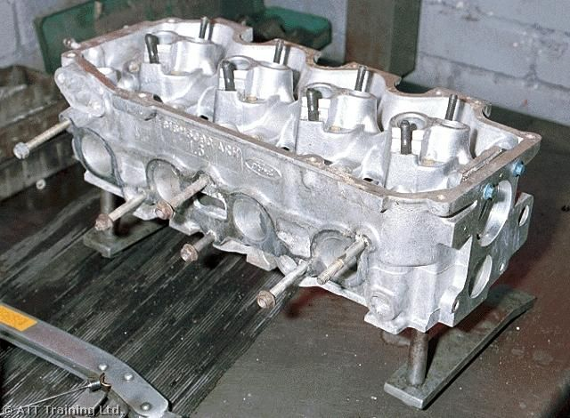
Write up of work carried out (continue on separate sheet if required):

PPE worn: |  |  |  |  | Special tools used:
Details of technical data/tightening torques used: |  |  |  |  | Further faults found:
Cylinder head bolt tightening sequence:
Cylinder head bolt tightening torque:
Oil type and capacity:
I confirm that the work carried out on this data collection sheet was of the required standard |  |  | Assessor Name: |  |  | Assessor PIN: |  |  |  | Date:

Knowledge Assessment Unit L103 Learner Name:

Assessment criteria covered: AC2.1, 2.2, 2.3, 3.1, 3.3 & 3.4

1. State the purpose of the following components used in petrol engines: (16 marks)

a. Cylinder Head -

b. Camshaft -

c. Crankshaft -

d. Inlet Valves -

e. Piston -

f. Piston Rings -

g. Connecting Rod -

h. Valve Springs -

2. Outline the main purpose for each of the following systems: (8 marks)

a. Cooling System -

b. Lubrication System -

c. Fuel System -

d. Ignition System -

3. State the operating cycle of the 4-stroke petrol engine: (4 marks)

4. Give an example of valve and ignition timing for a petrol engine (state engine details): (10 marks)

5. Give examples of the correct air / fuel ratio for each of the following situations: (4 marks)

a. Cold Start -

b. Idling (normal operating temperature) -

c. Hard Acceleration -

d. Overrun -

6. State the four main harmful constituents of petrol engine exhaust emissions and the effect they have on
animal life and the environment (8 marks)

1. 2.

3. 4.

I confirm that the work carried out on this knowledge assessment sheet was of the required standard

Assessor Name:

Assessor PIN: Date:

PRACTICAL ASSESSMENT ASSESSOR RECORD:

L103 Spark Ignition Engine Systems, Components and Operation

LO: | Assessment Criteria
1 | 1.1 Use appropriate PPE and VPE when working on SI engines  1.2 Use appropriate and safe working practices when working on SI engine mechanical systems
2 | 2.1 Identify the main components used in SI engines  2.2 State the purpose of the main components used in SI engines  2.3 Outline the purpose of the main systems used in SI engines
3 | 3.1 State the operating cycle of the 2 and 4 stroke SI engines  3.2 Give examples of the valve and ignition timing requirements for 4 stroke SI engines  3.3 State the correct air/fuel mixture for SI engines during different situations  3.4 Identify the constituents of SI exhaust gas emissions and their effects on the environment.
4 | 4.1 Select the correct technical data for SI engine maintenance  4.2 Demonstrate the correct procedures when removing and refitting an SI engine cylinder head from a fully equipped non running stand engine  4.3 Demonstrate the correct procedures for reinstating the engine and vehicle after SI engine maintenance

The section below is for use by the assessor:
Assessment Outcome: |  |  |  |  |  | Passed (Tick√)
1 | Be able to work safely on SI engines
2 | Know SI engine systems and components
3 | Understand how SI engines operate
4 | Be able to safely and correctly carryout routine SI engine maintenance
Assessor Name (Print) |  |  | Tick (√) | Written feedback (with reference to assessment criteria) must be given when a learner is referred:
PASS
I confirm that the learner’s work was to an acceptable standard and met the assessment criteria of the unit
REFER
The work carried out did not achieve the standards specified by the assessment criteria (written feedback to learner)
Assessor Name (Print): |  |  |  |  | Assessor PIN: | Date:
The section below is only to be completed once the assessor decision has been made and feedback given to learner:
The section below is to be completed by the learner:
I confirm that the work carried out was my own, and that I received feedback from the Assessor |  | Learner name (Print): |  |  | Learner Signature: |  | Date:

LEARNER WORK SHEET

Unit No: L104
CI ENGINE SYSTEMS, COMPONENTS AND OPERATION

Diesel Engine Cylinder Head Removal and Re-fitment

Learner Name: |  |  |  |  |  |  |  | Date work carried out:
Assessment criteria covered: Unit L104 – AC 3.4 & 4.1
Vehicle Details |  |  |  |  |  |  |  |  | Description of work required/customer request:  1. Remove and refit a basic CI engine cylinder head to a static engine
Reg No: |  |  |  | VIN/Eng No:
Make:
Model:
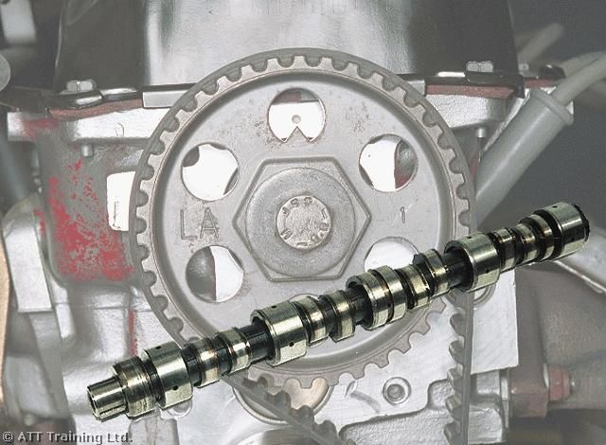
Write up of work carried out (continue on separate sheet if required):

PPE worn: |  |  |  |  | Special tools used:
Details of technical data/tightening torques used: |  |  |  |  | Further faults found:
Cylinder head bolt tightening sequence:
Cylinder head bolt tightening torque:
Oil type and capacity:
I confirm that the work carried out on this data collection sheet was of the required standard |  |  | Assessor Name: |  |  | Assessor PIN: |  |  |  | Date:

Knowledge Assessment Unit L104 Learner Name:

Assessment criteria covered: AC 2.2, 2.3, 3.1, 3.2, 3.3 & 3.4

1. State the purpose of the following components used in diesel engines: (16 marks)

Cylinder Head -

Camshaft -

Crankshaft -

Inlet Valves -

Piston -

Piston Rings -

Connecting Rod -

Valve Springs -

2. Outline the main purpose for each of the following systems: (8 marks)

Cooling System -

Lubrication System -

Fuel System -

Air Induction System -

3. State the operating cycle of the 4-stroke diesel engine: (4 marks)

4. Give an example of valve and injection timing for a diesel engine (state engine details): (8 marks)

5. What is the major difference in fuelling between SI and CI during the induction stroke? (1 mark)

6. What happens near the end of the compression stroke on a CI engine, which does not happen with a standard
SI engine? (1 mark)

7 State the five main harmful constituents of diesel engine exhaust emissions and the effect they have on
animal life and the environment (10 marks)

8. Why can CI engines be more easily pressure charged compared to SI engines, without fear of detonation?
(2 marks)

I confirm that the work carried out on this knowledge assessment sheet was of the required standard

Assessor Name:

Assessor PIN: Date:

PRACTICAL ASSESSMENT ASSESSOR RECORD:

L104 CI ENGINE SYSTEMS, COMPONENTS AND OPERATION

LO: | Assessment Criteria
1 | 1.1 Use appropriate PPE and VPE when working on CI engines  1.2 Use appropriate and safe working practices when working on CI engine mechanical systems
2 | 2.1 Identify the main components used in CI engines  2.2 State the purpose and function of the main components used in CI engines  2.3 Outline the purpose of the systems used in CI engines
3 | 3.1 State the operating cycles of the 2 and 4 stroke CI engine  3.2 Give examples of the valve and injection timing requirements for 4 stroke CI engines  3.3 State how air to fuel ratios differ from SI engines during different situations  3.4 Identify the constituents of CI exhaust gas emissions and their effects on the environment
4 | 4.1 Select the correct technical data for CI engine maintenance  4.2 Demonstrate the correct procedures when removing and refitting an CI engine cylinder head from a non running stand engine  4.3 Demonstrate the correct procedures for reinstating the engine and vehicle after CI engine maintenance

The section below is for use by the assessor:
Assessment Outcome: |  |  |  |  |  | Passed (Tick√)
1 | Be able to work safely on CI engines
2 | Know CI engine systems and components
3 | Understand how CI engines operate
4 | Be able to remove and refit a CI engine cylinder head
Assessor Name (Print) |  |  | Tick (√) | Written feedback (with reference to assessment criteria) must be given when a learner is referred:
PASS
I confirm that the learner’s work was to an acceptable standard and met the assessment criteria of the unit
REFER
The work carried out did not achieve the standards specified by the assessment criteria (written feedback to learner)
Assessor Name (Print): |  |  |  |  | Assessor PIN: | Date:
The section below is only to be completed once the assessor decision has been made and feedback given to learner:
The section below is to be completed by the learner:
I confirm that the work carried out was my own, and that I received feedback from the Assessor |  | Learner name (Print): |  |  | Learner Signature: |  | Date:

LEARNER WORK SHEET

Unit No: L105 TASK 1
ENGINE LIQUID COOLING AND LUBRICATION SYSTEMS COMPONENTS AND OPERATION

Cooling System Component Replacement

Learner Name: |  |  |  |  |  |  |  | Date work carried out:
Assessment criteria covered: Unit L105 – AC 1.1, 1.2, 4.1 – 4.4
Vehicle Details |  |  |  |  |  |  |  |  | Description of work required/customer request:  - Remove and refit a radiator and thermostat to an operational engine.  - Remove and refit a water pump drive-belt, and tension.  - Pressure test the system for leaks
Reg No: |  |  |  | VIN/Eng No:
Make:
Model:
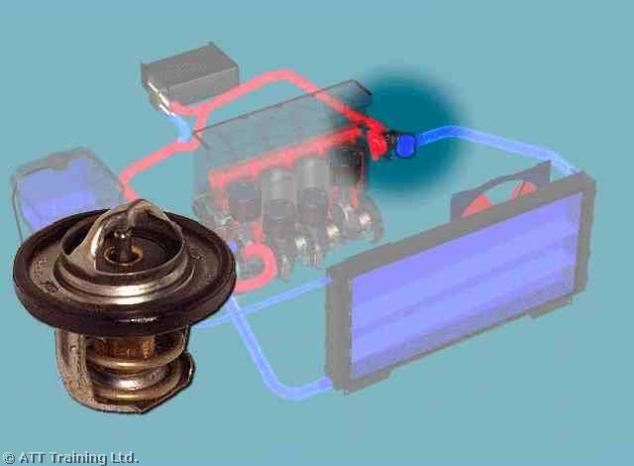
Write up of work carried out (continue on separate sheet if required):

PPE worn: |  |  |  |  | Special tools used:
Details of technical data/tightening torques used: |  |  |  |  | Further faults found:
Coolant capacity:
Thermostat opening temperature:
Cooling system maximum cap pressure:
I confirm that the work carried out on this data collection sheet was of the required standard |  |  | Assessor Name: |  |  |  | Assessor PIN: |  |  | Date:

LEARNER WORK SHEET

Unit No: L105 TASK 2
ENGINE LIQUID COOLING AND LUBRICATION SYSTEMS, COMPONENTS AND OPERATION

Lubrication System Component Replacement

Learner Name: |  |  |  |  |  |  |  | Date work carried out:
Assessment criteria covered: Unit L105 – AC 1.1, 1.2, 5.1 - 5.4
Vehicle Details |  |  |  |  |  |  |  |  | Description of work required/customer request:  1. Change engine oil and filter  2. Examination of engine for suspect  oil leak  3. Remove and replace a gasket on an  engine component.
Reg No: |  |  |  | VIN/Eng No:
Make:
Model:
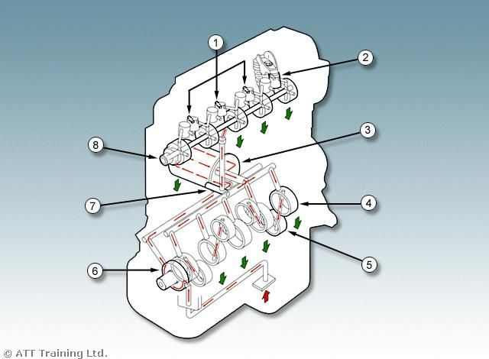
Write up of work carried out (continue on separate sheet if required):

PPE worn: |  |  |  |  | Special tools used:
Details of technical data/tightening torques used: |  |  |  |  | Further faults found:
Lubrication capacity:
Type and grade of oil:
Engine oil pressure:
I confirm that the work carried out on this data collection sheet was of the required standard |  |  | Assessor Name: |  |  |  | Assessor PIN: |  |  | Date:

Knowledge Assessment Unit L105 Learner Name:

Liquid Cooling Systems Assessment criteria covered: AC 2.1, 2.2, 2.3, 2.4, 3.1 & 3.2

1. State the purpose of the following components used in the cooling system: (16 marks)

a. Radiator -

b. Thermostat -

c. Water Pump -

d. Hoses -

e. Fan -

f. Expansion Tank -

g. Antifreeze -

h. Heater matrix -

2. Give an overview of how the engine liquid cooling system works: (9 marks)

I confirm that the work carried out on this knowledge assessment sheet was of the required standard

Assessor Name:

Assessor PIN: Date:

Knowledge Assessment Unit L105 Learner Name:

Lubrication Systems Assessment criteria covered: AC 2.3, 2.4 & 3.2

3. State the purpose of the following components used in the lubrication system: (16 marks)

a. Oil -

b. Pressure Gauge -

c. Oil Pump -

d. Oil Cooler -

e. Oil Filter -

f. Engine Breather -

g. Sump -

h. Pressure Relief Valve -

4. State the operating principles of the engine lubrication system: (9 marks)

I confirm that the work carried out on this knowledge assessment sheet was of the required standard

Assessor Name:

Assessor PIN: Date:

PRACTICAL ASSESSMENT ASSESSOR RECORD:

L105 Engine Liquid Cooling & Lubrication System Components and Operation

LO: | Assessment Criteria
1 | 1.1 Use appropriate PPE and VPE when working on engine liquid cooling and lubrication systems  1.2 Use appropriate and safe working practices when working on engine liquid cooling and lubrication systems
2 | 2.1 Identify the main components used in engine liquid cooling systems  2.2 State the purpose of the main components used in engine liquid cooling systems  2.3 Identify the main components used in engine lubrication systems  2.4 State the purpose of the main components used in engine lubrication systems
3 | 3.1. State the operating principles of engine liquid cooling systems  3.2. State the operating principles of engine lubrication systems
4 | 4.1. Select the correct technical data for routine maintenance of liquid cooling systems  4.2. Demonstrate the correct procedures when removing and refitting an engine liquid cooling system radiator and thermostat and refilling the cooling system correctly  4.3. Demonstrate the correct procedures for tensioning the coolant drive belts  4.4. Demonstrate the correct procedures for pressure testing the cooling systems and checking for leaks
5 | 5.1. Select the correct technical data for routine maintenance or engine lubrication systems  5.2. Demonstrate the correct procedures when changing the oil and filter on a vehicle  5.3. Demonstrate the correct procedures when replacing a gasket on an engine component  5.4. Demonstrate the correct procedures when inspecting an engine for leaks

The section below is for use by the assessor:
Assessment Outcome: |  |  |  |  |  | Passed (Tick√)
1 | Be able to work safely on engine liquid cooling and lubrication systems
2 | Know about engine liquid cooling and lubrication systems
3 | Know how engine liquid cooling and lubrication systems operate
4 | Be able to carryout routine maintenance on engine liquid cooling systems
5 | Be able to carryout routine maintenance on engine lubrication systems
Assessor Name (Print) |  |  | Tick (√) | Written feedback (with reference to assessment criteria) must be given when a learner is referred:
PASS
I confirm that the learner’s work was to an acceptable standard and met the assessment criteria of the unit
REFER
The work carried out did not achieve the standards specified by the assessment criteria (written feedback to learner)
Assessor Name (Print): |  |  |  |  | Assessor PIN: | Date:
The section below is only to be completed once the assessor decision has been made and feedback given to learner:
The section below is to be completed by the learner:
I confirm that the work carried out was my own, and that I received feedback from the Assessor |  | Learner name (Print): |  |  | Learner Signature: |  | Date:

LEARNER WORK SHEET

Unit No: L106 TASK 1
STEERING AND SUSPENSION SYSTEMS, COMPONENTS AND MAINTENANCE (4 WHEELS OR MORE)

Steering System Component Adjustment/Replacement

Learner Name: |  |  |  |  |  |  |  | Date work carried out:
Assessment criteria covered: Unit L106 – AC 1.1, 1.2, 4.1 – 4.4
Vehicle Details |  |  |  |  |  |  |  |  | Description of work required/customer request:  1. Remove and replace a track rod end.  2. Adjust the front wheel alignment to within manufacturers tolerance  3. Check and top up power steering fluid level
Reg No: |  |  |  | Steering system type (Box/rack):
Make:
Model:
VIN/Eng No:
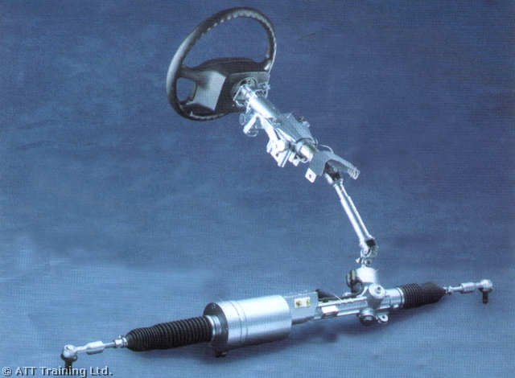
Write up of work carried out (continue on separate sheet if required): |  |  |  |  |  |  |  |  | Checks to be carried out prior to checking/adjusting wheel alignment:  1.  2.  3.  4.  5.  6.
PPE worn: |  |  |  |  | Special tools used:
Details of technical data/tightening torques used: |  |  |  |  | Further faults found:
Wheel Alignment Data:
Tyre Pressures:
Power Steering Fluid Type:
I confirm that the work carried out on this data collection sheet was of the required standard |  |  | Assessor Name: |  |  |  | Assessor PIN: |  |  | Date:

LEARNER WORK SHEET

Unit No: L106 TASK 2
STEERING AND SUSPENSION SYSTEMS, COMPONENTS AND MAINTENANCE (4 WHEELS OR MORE)

Suspension System Component Replacement

Learner Name: |  |  |  |  |  |  |  | Date work carried out:
Assessment criteria covered: Unit L106 – AC 1.1, 1.2, 5.1 – 5.3
Vehicle Details |  |  |  |  |  |  |  |  | Description of work required/customer request:  1. Remove and replace a complete suspension strut.  2. Check suspension system for leaks and obvious defects
Reg No: |  |  |  | Suspension system type:
Make: |  |  |  | VIN/Eng No:
Model:
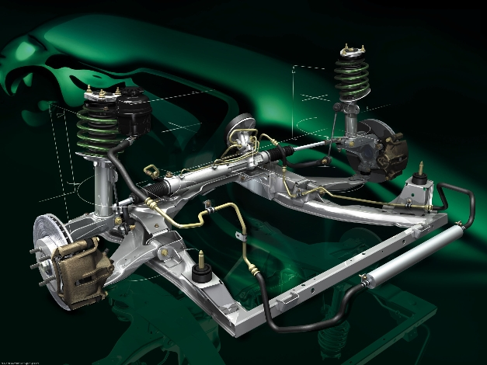
Write up of work carried out (continue on separate sheet if required): |  |  |  |  |  |  |  |  | Items to be checked on a suspension system:  1.  2.  3.  4.  5.  6.
PPE worn: |  |  |  |  | Special tools used:
Details of technical data/tightening torques used: |  |  |  |  | Further faults found:
Wheel tightening torque data:
Tyre pressures:
Strut top nut tightening torque data:
I confirm that the work carried out on this data collection sheet was of the required standard |  |  | Assessor Name: |  |  |  | Assessor PIN: |  |  | Date:

Knowledge Assessment Unit L106 Learner Name:

Steering Systems Assessment criteria covered: AC 2.1, 2.2 & 3.1

1. State the purpose of the following main components used in steering systems: (12 marks)

a. Steering Column -

b. Steering Gearbox -

c. Ball Joints -

d. Steering Joints and Couplings -

e. Rubber Gaiters -

f. Track Rod -

2. Identify the following steering angles and state their purpose:(12 marks)
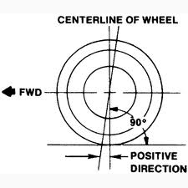
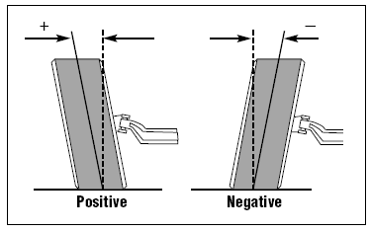
a. b.

Angle: Angle:

Purpose: Purpose:

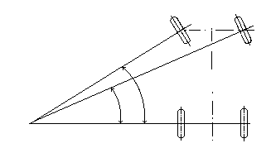
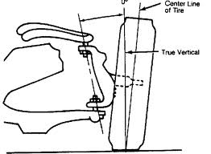
c. d.

Angle: Angle:

Purpose: Purpose:

I confirm that the work carried out on this knowledge assessment sheet was of the required standard

Assessor Name:

Assessor PIN: Date:

Knowledge Assessment Unit L106 Learner Name:

Suspension systems Assessment criteria covered: AC 2.3, 2.4 & 3.1

3. Identify the following suspension components and state their purpose:(12 marks)
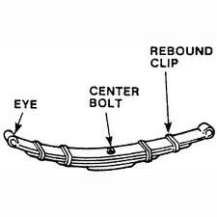
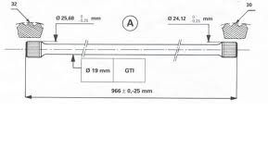
a. b.

Item: Item:

Purpose: Purpose:
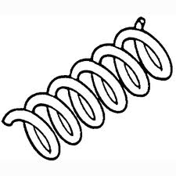
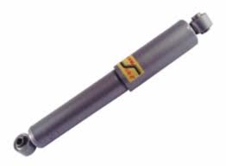
c. d.

Item: Item:

Purpose: Purpose:

4. What does IFS stand for and give two advantages for this system? (3 marks)

5. What does IRS stand for and give two advantages for this system? (3 marks)

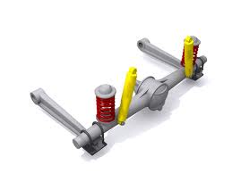

6. Identify the assembly shown in the diagram (4 marks)

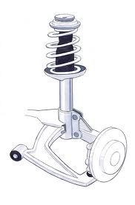
7. Identify the type of suspension system shown in the diagram (4 marks)

I confirm that the work carried out on this knowledge assessment sheet was of the required standard

Assessor Name:

Assessor PIN: Date:

PRACTICAL ASSESSMENT ASSESSOR RECORD:

L106 Steering and Suspension Systems Components and Maintenance

(4 wheels or more)

LO: | Assessment Criteria
1 | 1.1 Use appropriate PPE when working on steering and suspension systems  1.2 Use appropriate and safe working practices when working on vehicle steering and suspension systems
2 | 2.1 Identify the main components used in non-assisted steering systems  2.2 State the purpose of the main components used in non-assisted steering systems  2.3 Identify the main components used in common suspension systems  2.4 State the purpose of the main components used in common suspension systems
3 | 3.1 State the operating principles of non-assisted steering systems and components  3.2 State the operating principles of suspension systems and components
4 | 4.1 Select the correct technical data for routine maintenance of steering systems  4.2 Demonstrate the correct procedures when removing and refitting a track rod end  4.3 Demonstrate the correct procedures for adjusting front wheel alignment (toe) to within manufacturers tolerance  4.4 Demonstrate the correct procedures for checking and topping up power steering fluid levels
5 | 5.1 Select the correct technical data for routine maintenance of suspension systems  5.2 Demonstrate the correct procedures to check suspension systems for leaks and visually obvious defects  5.3 Demonstrate the correct procedures when removing and refitting a complete suspension strut

The section below is for use by the assessor:
Assessment Outcome: |  |  |  |  |  | Passed (Tick√)
1 | Be able to work safely on steering and suspension systems
2 | Know about non-assisted steering and suspension components
3 | Know how non-assisted steering and suspension systems operate
4 | Be able to carryout routine maintenance on steering systems
5 | Be able to carryout routine maintenance on suspension systems
Assessor Name (Print) |  |  | Tick (√) | Written feedback (with reference to assessment criteria) must be given when a learner is referred:
PASS
I confirm that the learner’s work was to an acceptable standard and met the assessment criteria of the unit
REFER
The work carried out did not achieve the standards specified by the assessment criteria (written feedback to learner)
Assessor Name (Print): |  |  |  |  | Assessor PIN: | Date:
The section below is only to be completed once the assessor decision has been made and feedback given to learner:
The section below is to be completed by the learner:
I confirm that the work carried out was my own, and that I received feedback from the Assessor |  | Learner name (Print): |  |  | Learner Signature: |  | Date:

LEARNER WORK SHEET

Unit No: L107 VEHICLE BRAKING SYSTEMS COMPONENTS AND MAINTENANCE

Vehicle Braking System Component Replacement

Learner Name: |  |  |  |  |  |  |  | Date work carried out:
Assessment criteria covered: Unit L107 – AC 1.1,1.2, 4.1 – 4.4
Vehicle Details |  |  |  |  |  |  |  |  | Description of work required/customer request:  1. Remove and replace a set of pads  and a set of brake shoes  2. Adjust the handbrake mechanism  3. Demonstrate how to bleed a single brake component
Reg No: |  |  |  | Braking system type  (ABS or Non ABS)
Make: |  |  |  | VIN/Eng No:
Model:
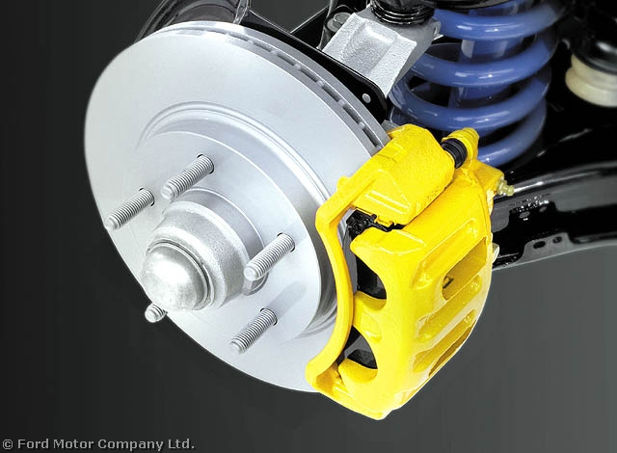
Write up of work carried out (continue on separate sheet if required): |  |  |  |  |  |  |  |  | Items to be checked while carrying out a brake inspection  1.  2.  3.  4.  5.  6.
PPE worn: |  |  |  |  | Special tools used:
Details of technical data/tightening torques used: |  |  |  |  | Further faults found
Road Wheel tightening torque Data:
Disc thickness:
Brake Fluid Type:
I confirm that the work carried out on this data collection sheet was of the required standard |  |  | Assessor Name: |  |  |  | Assessor PIN: |  |  | Date:

Knowledge Assessment Unit L107 Learner Name:

Assessment criteria covered: AC 2.1, 2.2, 3.1 & 3.2

1. What is meant by kinetic energy? (2 marks)

2. What does coefficient of friction mean? (2 marks)

3. Give the advantages of drum brakes: (4 marks)

4. Give the advantages of disc brakes: (4 marks)

5. How do pads retract? (2 marks)

6. During moderate braking, what is the approximate brake force distribution between the front brakes and rear brakes? (2 marks)
(please circle correct answer)

Front 20% Rear 80%

Front 60% Rear 40%

Front 80% Rear 20%

7. Approximately when should brake fluid be changed? (2 marks)

8. What is the purpose of the following components? (20 marks)

a. Master Cylinder –

b. Wheel Cylinder –

c. Brake Caliper –

d. Pressure Regulating Valve –

e. Brake Servo –

9. Draw TWO diagrams showing two different split braking systems (12 marks)

I confirm that the work carried out on this knowledge assessment sheet was of the required standard

Assessor Name:

Assessor PIN: Date:

PRACTICAL ASSESSMENT ASSESSOR RECORD:

L107 Vehicle Braking Systems Components and Maintenance

LO: | Assessment Criteria
1 | 1.1 Use appropriate PPE when working on vehicle braking systems  1.2 Use appropriate and safe working practices when working on vehicle braking systems
2 | 2.1 Identify the main mechanical components used in vehicle braking systems  2.2 Identify the main hydraulic components in non-ABS vehicle braking systems
3 | 3.1 State the operating principles of mechanical vehicle braking systems and components  3.2 State the operating principles of non-ABS hydraulic braking systems and components
4 | 4.1 Select the correct technical data for routine maintenance of vehicle braking systems  4.2 Demonstrate the correct procedures when removing and replacing brake pads and brake shoes  4.3 Demonstrate the correct procedures when adjusting handbrake mechanisms  4.4 Demonstrate the correct procedures for bleeding brakes during routine maintenance on vehicle  braking systems

The section below is for use by the assessor:
Assessment Outcome: |  |  |  |  |  | Passed (Tick√)
1 | Be able to work safely on vehicle braking systems
2 | Know non-ABS vehicle braking system components
3 | Know how basic vehicle braking systems operate
4 | Be able to carryout routine maintenance on vehicle braking systems
Assessor Name (Print) |  |  | Tick (√) | Written feedback (with reference to assessment criteria) must be given when a learner is referred:
PASS
I confirm that the learner’s work was to an acceptable standard and met the assessment criteria of the unit
REFER
The work carried out did not achieve the standards specified by the assessment criteria (written feedback to learner)
Assessor Name (Print): |  |  |  |  | Assessor PIN: | Date:
The section below is only to be completed once the assessor decision has been made and feedback given to learner:
The section below is to be completed by the learner:
I confirm that the work carried out was my own, and that I received feedback from the Assessor |  | Learner name (Print): |  |  | Learner Signature: |  | Date:

LEARNER WORK SHEET

Unit No: L108 ROUTINE VEHICLE MAINTENANCE PROCESSES AND PROCEDURES ON VEHICLES (4 WHEELS OR MORE)

Routine Maintenance

Learner Name: |  |  |  |  |  |  |  | Date work carried out:
Assessment criteria covered: Unit L108 – AC 1.1, 1.2, 2.1, 3.1, 4.1 - 4.4
Vehicle Details |  |  |  |  |  |  |  |  | Description of work required/customer request:  1. Using an inspection schedule sheet carry out an Interim service  2. Check and adjust the headlamp beam
Reg No: |  |  |  | VIN/Eng No:
Make:
Model:
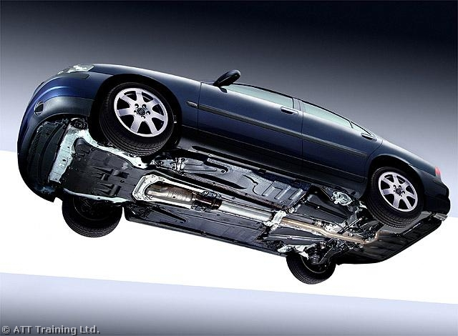
Write up of work carried out (continue on separate sheet if required): |  |  |  |  |  |  |  |  | List the correct type of fluid that should be used when topping up the following levels on an inspection  Brake fluid -  Power steering fluid -  Battery electrolyte -  Washer fluid -  Coolant -  Engine oil -  Transmission fluids –
PPE worn: |  |  |  |  | Special tools used:
Details of technical data/tightening torques used: |  |  |  |  | Further faults found:
Road Wheel tightening torque Data:
Tyre pressures:
Tyre tread depth:
I confirm that the work carried out on this data collection sheet was of the required standard |  |  | Assessor Name: |  |  |  | Assessor PIN: |  |  | Date:

PRACTICAL ASSESSMENT ASSESSOR RECORD:

L108 Routine Vehicle Maintenance Processes and Procedures on Vehicles

(4 wheels or more)

LO: | Assessment Criteria
1 | 1.1 Use appropriate PPE when carrying out routine vehicle maintenance  1.2 Use appropriate and safe working practices when carrying out routine vehicle maintenance
2 | 2.1 Identify the main components and systems found on a modern vehicle that require routine maintenance
3 | - Locate the correct and appropriate sources of information, tools and equipment required to carryout basic routine vehicle maintenance e.g. interim service
4 | 4.1. Locate and use the correct technical data when carrying out basic routine maintenance of vehicles e.g. interim service  4.2. Demonstrate the correct procedures when inspecting systems and components during basic routine vehicle maintenance.  - Demonstrate the correct procedures when replacing and replenishing fluids and service items during basic routine vehicle maintenance  - Demonstrate the correct procedures when adjusting and lubricating vehicle components and systems

The section below is for use by the assessor:
Assessment Outcome: |  |  |  |  |  | Passed (Tick√)
1 | Be able to work safely when carrying out routine vehicle maintenance
2 | Know vehicle components and systems that require routine maintenance
3 | Know routine maintenance requirements for vehicle systems and components
4 | Be able to carryout routine vehicle maintenance e.g. interim service
Assessor Name (Print) |  |  | Tick (√) | Written feedback (with reference to assessment criteria) must be given when a learner is referred:
PASS
I confirm that the learner’s work was to an acceptable standard and met the assessment criteria of the unit
REFER
The work carried out did not achieve the standards specified by the assessment criteria (written feedback to learner)
Assessor Name (Print): |  |  |  |  | Assessor PIN: | Date:
The section below is only to be completed once the assessor decision has been made and feedback given to learner:
The section below is to be completed by the learner:
I confirm that the work carried out was my own, and that I received feedback from the Assessor |  | Learner name (Print): |  |  | Learner Signature: |  | Date:

LEARNER WORK SHEET

Unit No: L109 VEHICLE WHEELS AND TYRES CONSTRUCTION

AND MAINTENANCE

Removal and Replacement of Wheels and Tyres

Learner Name: |  |  |  |  |  |  |  | Date work carried out:
Assessment criteria covered: Unit L109 – AC 1.1, 1.2, 4.1 – 4.5
Vehicle Details |  |  |  |  |  |  |  |  | Description of work required/customer request:  1. Remove and replace a road wheel  2. Remove and Replace a tubeless tyre  3. Balance a road wheel  4. Carry out a tyre inspection
Reg No: |  |  |  | VIN/Eng No:
Make:
Model:
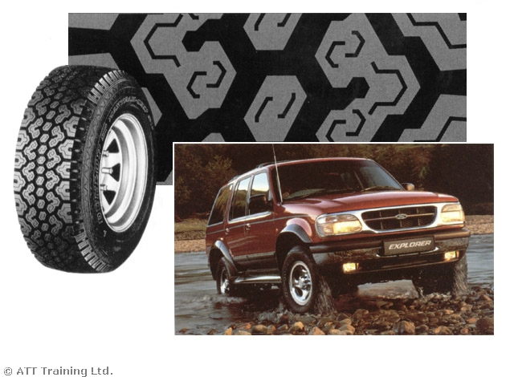
Write up of work carried out (continue on separate sheet if required): |  |  |  |  |  |  |  |  | List any road wheel rotation recommendations set by the manufacture of the vehicle.
PPE worn: |  |  |  |  | Special tools used:
Details of technical data/tightening torques used: |  |  |  |  | Further faults found:
Road Wheel tightening torque Data:
Tyre Depth:
Tyre Pressures:
I confirm that the work carried out on this data collection sheet was of the required standard |  |  | Assessor Name: |  |  |  | Assessor PIN: |  |  | Date:

Knowledge Assessment Unit L109 Learner Name:
Pass Mark 30
Assessment criteria covered: AC 2.1, 2.2, 2.3 & 3.1

1. Draw and label a simple diagram to show the construction of a radial ply tyre? (10 marks)

2. Draw and label a simple diagram to show the construction of a cross ply tyre? (10 marks)

3. Draw four different types of wheel in common use today: (20 marks)

4. Identify what these tyre markings mean:– 185/70 R 14 78H (10 marks)

a. 185 –

b. 70 –

c. 14 –

d. 78 –

e. H -

I confirm that the work carried out on this knowledge assessment sheet was of the required standard

Assessor Name:

Assessor PIN: Date:

PRACTICAL ASSESSMENT ASSESSOR RECORD:

L109 Vehicle Wheels and Tyres Construction and Maintenance

LO: | Assessment Criteria
1 | 1.1 Use appropriate PPE when working with road wheels and tyres wheels  1.2 Use appropriate and safe working practices when working with road wheels and tyres wheels
2 | 2.1 Identify the types of tyre used on common road vehicles  2.2 Identify the construction of radial and cross ply tyres  2.3 Identify the types of wheel used on road vehicles
3 | 3.1 Give examples of the markings and terminology associated with vehicle wheels and tyres
4 | 4.1. Select the correct technical information for maintaining wheels and tyres  4.2. Demonstrate the correct procedures to remove and refit a road wheel to a vehicle  4.3. Demonstrate correct procedures to remove and refit a standard tubeless tyre to a road wheel  4.4 Demonstrate correct procedures to balance a wheel and tyre to within acceptable tolerances  4.5. Demonstrate the correct method to check a tyres suitability and legality for fitment to a vehicle

The section below is for use by the assessor:
Assessment Outcome: |  |  |  |  |  | Passed (Tick√)
1 | Be able to work safely when working with road wheels and tyres
2 | Know how wheel and tyres are constructed
3 | Know wheel and tyre terminology
4 | Be able to carryout routine maintenance and replacement of road wheels and tyres
Assessor Name (Print) |  |  | Tick (√) | Written feedback (with reference to assessment criteria) must be given when a learner is referred:
PASS
I confirm that the learner’s work was to an acceptable standard and met the assessment criteria of the unit
REFER
The work carried out did not achieve the standards specified by the assessment criteria (written feedback to learner)
Assessor Name (Print): |  |  |  |  | Assessor PIN: | Date:
The section below is only to be completed once the assessor decision has been made and feedback given to learner:
The section below is to be completed by the learner:
I confirm that the work carried out was my own, and that I received feedback from the Assessor |  | Learner name (Print): |  |  | Learner Signature: |  | Date:

LEARNER WORK SHEET

Unit No: L110 VEHICLE EXHAUST SYSTEMS COMPONENTS

AND MAINTENANCE

Remove and Replace an Exhaust System

Learner Name: |  |  |  |  |  |  |  | Date work carried out:
Assessment criteria covered: Unit L110 – AC 1.1, 1.2 & 3.1
Vehicle Details |  |  |  |  |  |  |  |  | Description of work required/customer request:  1. Remove and replace a complete exhaust system
Reg No: |  |  |  | VIN/Eng No:
Make:
Model:
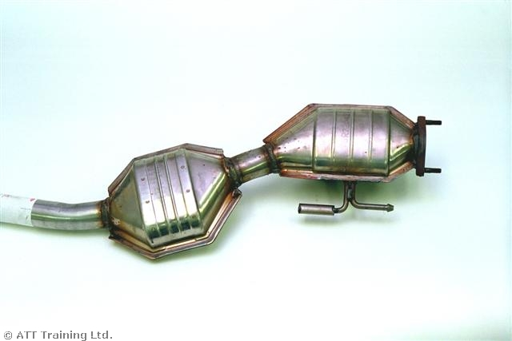

Write up of work carried out (continue on separate sheet if required): |  |  |  |  |  |  |  |  | Name five gases that are emitted from the exhaust pipe  1.  2.  3.  4.  5.
PPE worn: |  |  |  |  | Special tools used:
Details of technical data/tightening torques used: |  |  |  |  | Further faults found:
Manifold tightening torque:
Lambda tightening torque:
Front pipe to exhaust manifold tightening torque:
I confirm that the work carried out on this data collection sheet was of the required standard |  |  | Assessor Name: |  |  |  | Assessor PIN: |  |  | Date:

Knowledge Assessment Unit L110 Learner Name:
Pass Mark 30
Assessment criteria covered: AC 1.2 & 2.3

1. Match the numbers to the main components of the exhaust system shown here: (30 marks)

Component | Number
Exhaust manifold
Heat Shield
Front pipe
Silencer box
Catalytic converter
Exhaust system brackets
Exhaust system joints and gaskets

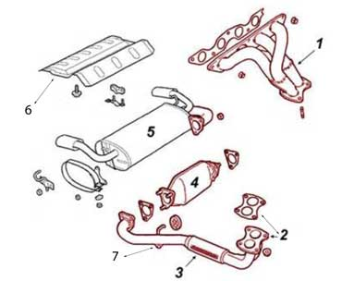

2. What is the purpose of each of the following? (20 marks)

a. Exhaust manifold -

b. Lambda sensor -

c. Silencer box -

d. Expansion box -

e. Catalytic converter -

f. Exhaust system brackets -

I confirm that the work carried out on this knowledge assessment sheet was of the required standard

Assessor Name:

Assessor PIN: Date:

PRACTICAL ASSESSMENT ASSESSOR RECORD:

L110 Vehicle Exhaust Systems Components and Maintenance

LO: | Assessment Criteria
1 | 1.1. Use appropriate PPE and VPE when removing and refitting exhaust systems  1.2. Use appropriate and safe working practices
2 | 2.1. Identify the components used in vehicle exhaust systems on modern SI engine vehicles  2.2 State the purpose of each major part of the exhaust system
3 | 3.1. Demonstrate the correct sequence and procedure for removing and refitting vehicle exhaust systems and components

The section below is for use by the assessor:
Assessment Outcome: |  |  |  |  |  | Passed (Tick√)
1 | Be able to work safely on vehicle exhaust systems
2 | Know exhaust systems components
3 | Be able to remove and refit exhaust systems
Assessor Name (Print) |  |  | Tick (√) | Written feedback (with reference to assessment criteria) must be given when a learner is referred:
PASS
I confirm that the learner’s work was to an acceptable standard and met the assessment criteria of the unit
REFER
The work carried out did not achieve the standards specified by the assessment criteria (written feedback to learner)
Assessor Name (Print): |  |  |  |  | Assessor PIN: | Date:
The section below is only to be completed once the assessor decision has been made and feedback given to learner:
The section below is to be completed by the learner:
I confirm that the work carried out was my own, and that I received feedback from the Assessor |  | Learner name (Print): |  |  | Learner Signature: |  | Date:

LEARNER WORK SHEET

Unit No: L111 VEHICLE DRIVELINE MAINTENANCE

Vehicle Driveline Maintenance

Learner Name: |  |  |  |  |  |  |  |  | Date work carried out:
Assessment criteria covered: Unit L111 – AC 3.1, 4.1 – 4.5
Vehicle Details |  |  |  |  |  |  |  |  |  | Description of work required/customer request:  1. Check and top up transmission fluid in a manual gearbox  2. Check and top up transmission fluid in a automatic gearbox  3. Remove and replace a clutch to a stand engine  4. Remove and replace a drive shaft boot or a propshaft joint.
Reg No: |  |  |  | VIN/Eng No:
Make:
Model:
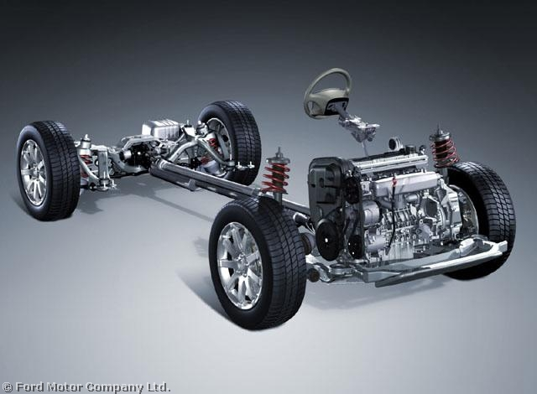

Write up of work carried out (continue on separate sheet if required): |  |  |  |  |  |  |  |  |  |  | Give four areas to inspect for fluid leaks on a transmission system:  1.  2.  3.  4.
PPE worn: |  |  |  |  |  | Special tools used:
Details of technical data/tightening torques used: |  |  |  |  |  | Further faults found:
Type of automatic transmission fluid:
Capacity of gearbox: |  | Manual |  |  | Auto
Type of gear oil:
I confirm that the work carried out on this data collection sheet was of the required standard |  |  | Assessor Name: |  |  |  |  | Assessor PIN: |  |  |  | Date:

Knowledge Assessment Unit L111 Learner Name:
Pass Mark 30
Assessment criteria covered:– AC 3.1, 3.2 & 3.3

1. Identify the range of components from a simple manual gearbox and clutch shown below (18 marks)
a. b.
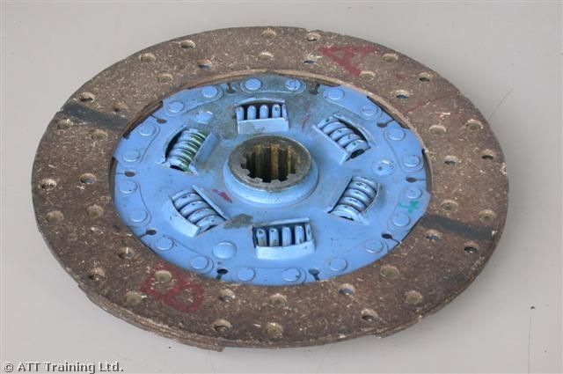 __________________________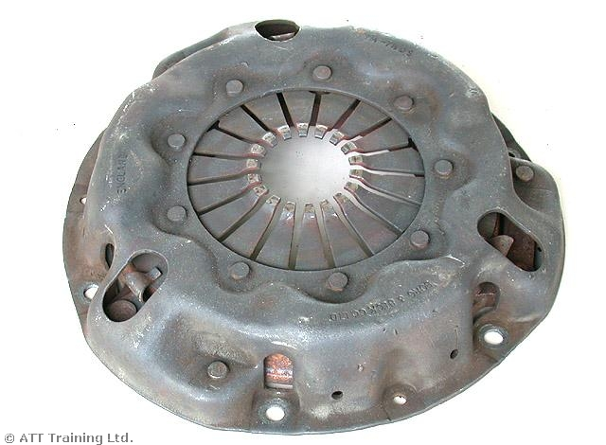

c. d.

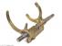
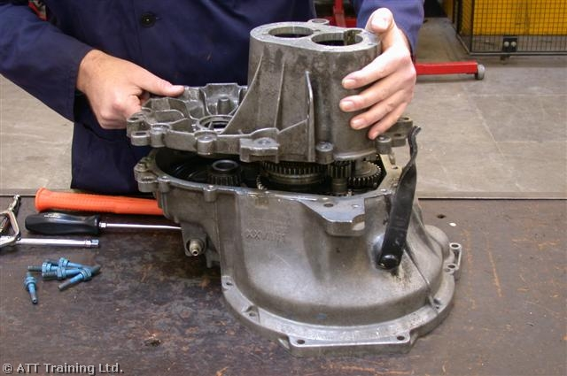 ----------------------------------------------- --------------------------------------

e. f.

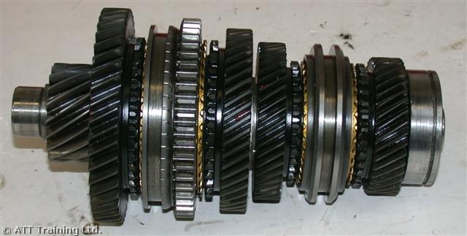
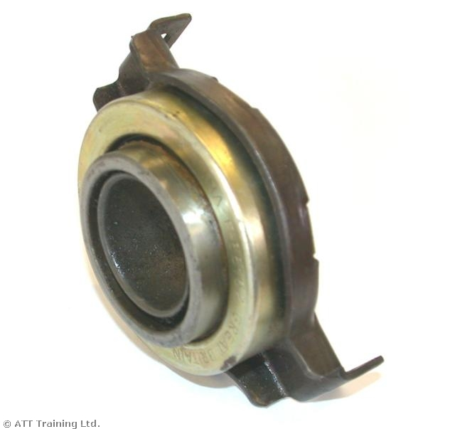 ------------------------------------------- -----------------------------------

2. Identify the range of components from a simple automatic gearbox shown below. (20 marks)

a. b.
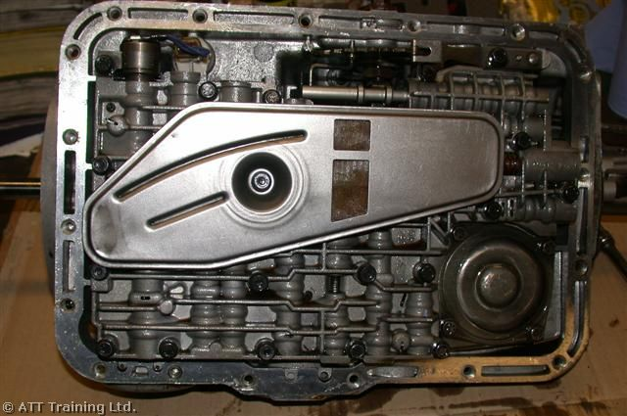
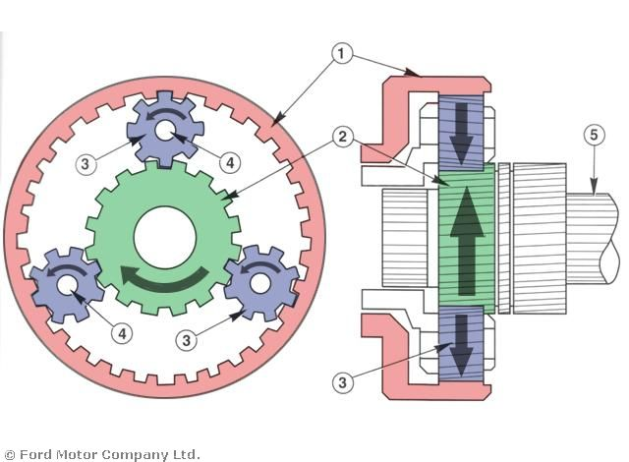 ------------------------------ -----------------------------------------

c. d.

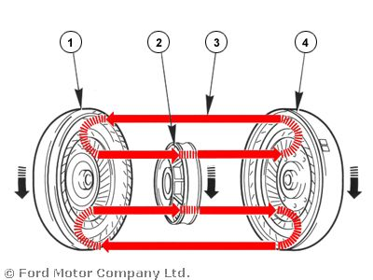
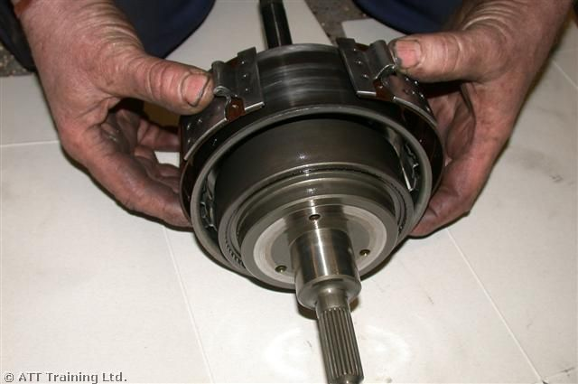 --------------------------- ---------------------------------------

3. State FOUR reasons why a gearbox is fitted to a vehicle (12 marks)

I confirm that the work carried out on this knowledge assessment sheet was of the required standard

Assessor Name:

Assessor PIN: Date:

PRACTICAL ASSESSMENT ASSESSOR RECORD:

L111 Vehicle Driveline Maintenance

LO: | Assessment Criteria
1 | 1.1 Use appropriate PPE when working on vehicle drivelines  1.2 Use appropriate and safe working practices when working on vehicle drivelines
2 | 2.1 Identify the range of units that make up the driveline assembly on FWD, RWD and 4 wheel drive vehicles  2.2 Locate the driveline components on FWD and RWD vehicles
3 | 3.1 State the purpose of the gearbox  3.2 Identify a range of components from a selection of simple manual gearbox and clutch parts  3.3 Identify a range of components from a selection of simple automatic gearbox and torque converter parts
4 | 4.1 Select appropriate information and technical data for routine driveline maintenance  4.2 Demonstrate the correct procedures to check and top up the levels in a manual gearbox  4.3 Demonstrate the correct procedures to check and top up the levels in an automatic gearbox  4.4 Demonstrate the correct procedures to remove and refit a clutch to a manual transmission vehicle (gearbox removed)  4.5 Demonstrate the correct procedures to remove and refit a drive shaft gaiter or propshaft joint (driveshaft or propshaft already removed)

The section below is for use by the assessor:
Assessment Outcome: |  |  |  |  |  | Passed (Tick√)
1 | Be able to work safely on transmission systems
2 | Know about vehicle drivelines
3 | Know about vehicle gearboxes
4 | Be able to carry out routine maintenance on vehicle drivelines
Assessor Name (Print) |  |  | Tick (√) | Written feedback (with reference to assessment criteria) must be given when a learner is referred:
PASS
I confirm that the learner’s work was to an acceptable standard and met the assessment criteria of the unit
REFER
The work carried out did not achieve the standards specified by the assessment criteria (written feedback to learner)
Assessor Name (Print): |  |  |  |  | Assessor PIN: | Date:
The section below is only to be completed once the assessor decision has been made and feedback given to learner:
The section below is to be completed by the learner:
I confirm that the work carried out was my own, and that I received feedback from the Assessor |  | Learner name (Print): |  |  | Learner Signature: |  | Date:

LEARNER WORK SHEET

Unit No: L112 SPARK IGNITION SYSTEM MAINTENANCE

Remove and Replace Ignition components

Learner Name: |  |  |  |  |  |  |  | Date work carried out:
Assessment criteria covered: Unit L112 – AC 1.1, 1.2, 3.1 - 3.6
Vehicle Details |  |  |  |  |  |  |  |  | Description of work required/customer request:  1. Remove and replace an ignition coil/ coil pack  2. Remove and test a set of HT leads  3. Remove, replace and set the gaps on a set of spark plugs  4. Start engine to check correct engine operation
Reg No: |  |  |  | VIN/Eng No:
Make:
Model:
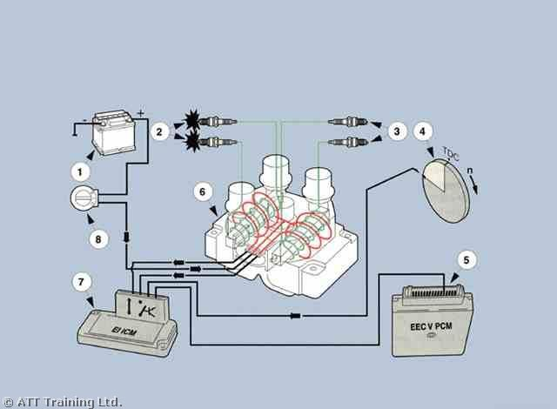

Write up of work carried out (continue on separate sheet if required): |  |  |  |  |  |  |  |  | List the readings obtained in measuring the resistance of the plug leads  1.  2.  3.  4.  5.  6.
PPE worn: |  |  |  |  | Special tools used:
Details of technical data/tightening torques used: |  |  |  |  | Further faults found:
Spark plug tightening torque Data:
Spark plug gap:
Spark plug type:
I confirm that the work carried out on this data collection sheet was of the required standard |  |  | Assessor Name: |  |  |  | Assessor PIN: |  |  | Date:

Knowledge Assessment Unit L112 Learner Name:
Pass Mark 30
Assessment criteria covered:– AC 2.1, 2.2 & 2.3

1. Identify the range of components of the ignition system shown below (20 marks)

a. b.

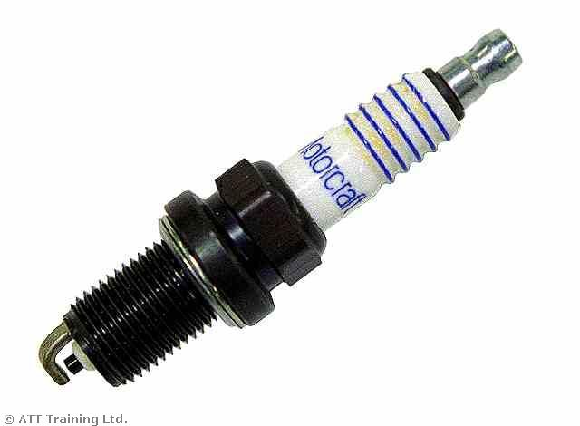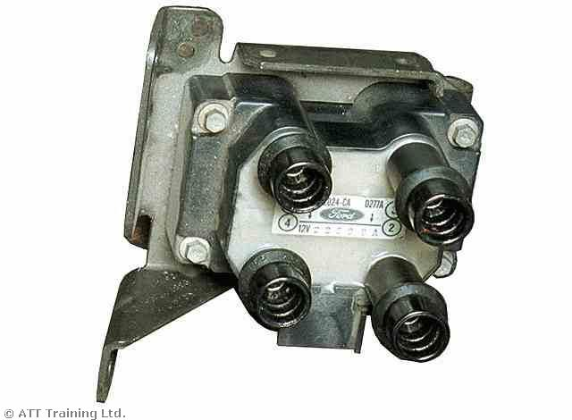

c. d.

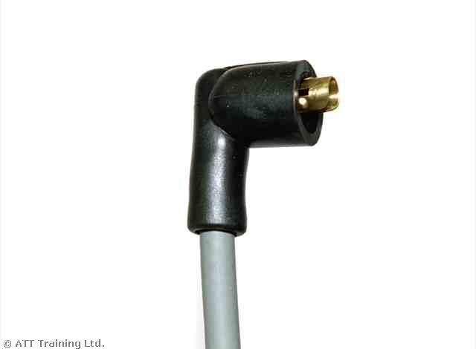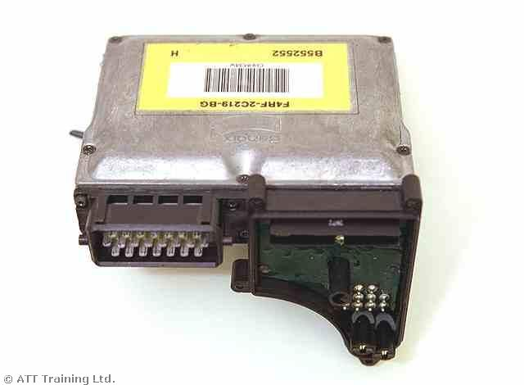

e.

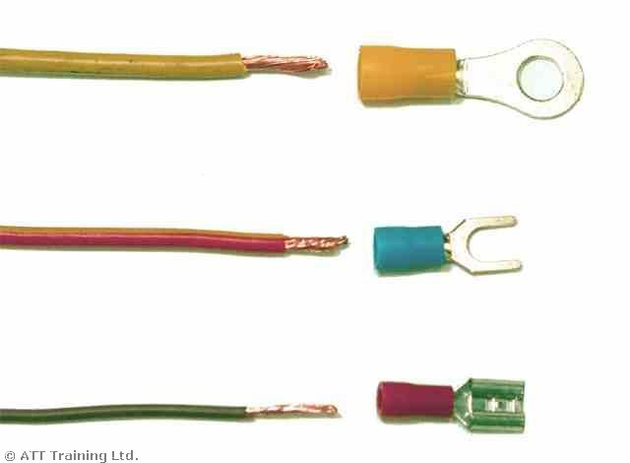

2. What is the purpose of each of the main components below. (30 marks)

a. Ignition coil -

b. HT Leads -

c. Spark Plugs -

d. ECU -

e. LT Leads -

I confirm that the work carried out on this knowledge assessment sheet was of the required standard

Assessor Name:

Assessor PIN: Date:

PRACTICAL ASSESSMENT ASSESSOR RECORD:

L112 Spark Ignition System Maintenance

LO: | Assessment Criteria
1 | 1.1 Use appropriate PPE when working on vehicle ignition systems  1.2 Use appropriate safe working practices when working with high voltage vehicle ignition systems
2 | 2.1 Identify and locate the main components on a distributor type vehicle ignition system  2.2 Identify the main components on a distributorless (DIS) ignition system  2.3 Outline the purpose of each main component
3 | 3.1 Remove and replace an ignition coil  3.2 Remove, inspect and measure the resistance of an HT lead using correct equipment  3.3 Remove and replace easily accessible spark plugs  3.4 Select correct type of spark plugs for engine being worked on by using technical data  3.5 Set the spark plug electrode gaps to within manufacturers tolerances  3.6 Start engine to check correct engine operation and throttle response

The section below is for use by the assessor:
Assessment Outcome: |  |  |  |  |  | Passed (Tick√)
1 | Be able to work safely when working on vehicle ignition systems
2 | Know about vehicle ignition systems
3 | Be able to replace vehicle ignition components
Assessor Name (Print) |  |  | Tick (√) | Written feedback (with reference to assessment criteria) must be given when a learner is referred:
PASS
I confirm that the learner’s work was to an acceptable standard and met the assessment criteria of the unit
REFER
The work carried out did not achieve the standards specified by the assessment criteria (written feedback to learner)
Assessor Name (Print): |  |  |  |  | Assessor PIN: | Date:
The section below is only to be completed once the assessor decision has been made and feedback given to learner:
The section below is to be completed by the learner:
I confirm that the work carried out was my own, and that I received feedback from the Assessor |  | Learner name (Print): |  |  | Learner Signature: |  | Date:

LEARNER WORK SHEET

Unit No: L113 VEHICLE ELECTRICAL FOUNDATION SKILLS

Wiring and Testing a Simple Electrical Circuit

Learner Name: |  |  |  |  |  |  |  | Date work carried out:
Assessment criteria covered: Unit L113 – AC 1.1, 1.2, 2.1, 2.2, 3.1 - 3.5
Vehicle Details |  |  |  |  |  |  |  |  | Description of work required/customer request:  1. Follow the diagrams to construct the parallel and series circuit  2. Use correct methods to crimp terminals to each end of the wire  3. Check the circuits using a volt meter and ammeter at various points around the circuit
Reg No: |  |  |  | VIN/Eng No:
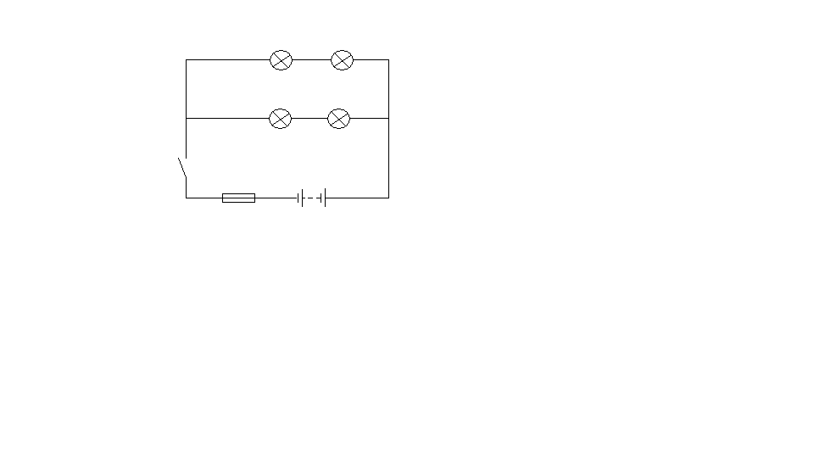
Make:
Model:
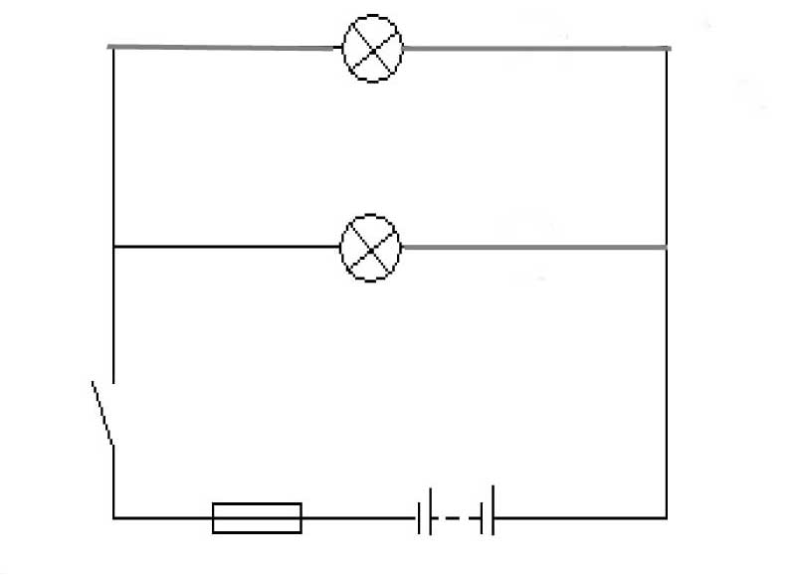
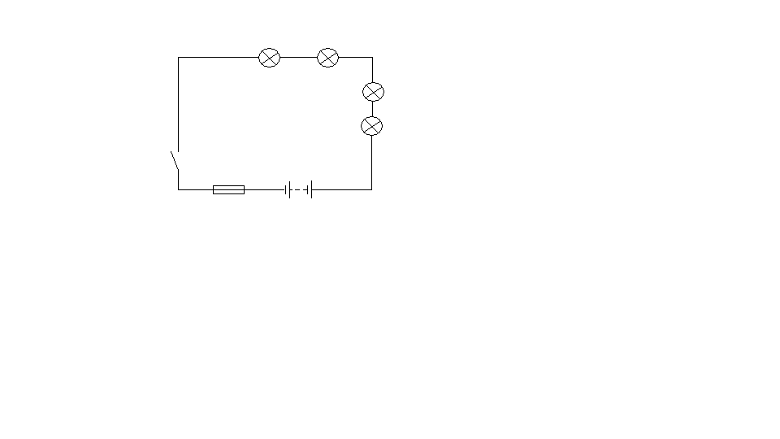
Parallel Circuit
Series Circuit |  |  |  |  |  |  |  |  | List the readings obtained in measuring the circuit  1.  2.  3.  4.  5.  6.
PPE worn: |  |  |  |  | Special tools used:
Details of technical data used: |  |  |  |  | Further faults found:
Data: Bulb Rating
Data: Fuse rating
Data: Wire Size
I confirm that the work carried out on this data collection sheet was of the required standard |  |  | Assessor Name: |  |  |  | Assessor PIN: |  |  | Date:
Knowledge Assessment Unit L113 Learner Name:
Pass Mark 30
Assessment criteria covered: – AC 2.3 & 2.4

1. Give the four main electrical units of measurement (20 marks)

2. Identify the electrical symbols shown below. (30 marks)

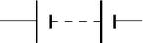
a.

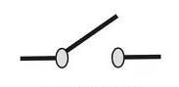
b.

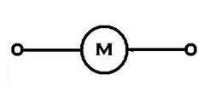
c.

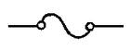
d.

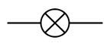
e.


f.

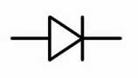
g.

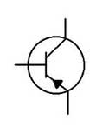

h.


i.

I confirm that the work carried out on this knowledge assessment sheet was of the required standard

Assessor Name:

Assessor PIN: Date:

PRACTICAL ASSESSMENT ASSESSOR RECORD:

L113 Vehicle Electrical Foundation Skills

LO: | Assessment Criteria
1 | 1.1 Use appropriate PPE when working on 12 volt electrical systems  1.2 Use appropriate and safe working practices when working on electrical systems
2 | 2.1 Identify the main electrical systems and components on a modern vehicle  2.2 Outline simple vehicle electrical principles and laws  2.3 State the main electrical units of measurement  2.4 Identify common electrical symbols
3 | 3.1 Select the correct size cable and fuses for a given circuit  - Demonstrate the ability to accurately read and interpret a simple wiring diagram  - Demonstrate the correct procedures to make a simple 12 volt lighting circuit using cable, switches, fuses, a relay and bulbs  - Demonstrate the correct use of a voltmeter and ammeter when checking electrical circuit operation  - Demonstrate the correct methods to crimp terminals to each end of a length of wire

The section below is for use by the assessor:
Assessment Outcome: |  |  |  |  |  | Passed (Tick√)
1 | Be able to work safely on vehicle electrical systems
2 | Know about vehicle electrical systems and electrical principles
3 | Be able to make simple electrical circuits
Assessor Name (Print) |  |  | Tick (√) | Written feedback (with reference to assessment criteria) must be given when a learner is referred:
PASS
I confirm that the learner’s work was to an acceptable standard and met the assessment criteria of the unit
REFER
The work carried out did not achieve the standards specified by the assessment criteria (written feedback to learner)
Assessor Name (Print): |  |  |  |  | Assessor PIN: | Date:
The section below is only to be completed once the assessor decision has been made and feedback given to learner:
The section below is to be completed by the learner:
I confirm that the work carried out was my own, and that I received feedback from the Assessor |  | Learner name (Print): |  |  | Learner Signature: |  | Date:

LEARNER WORK SHEET

Unit No: L114 VEHICLE LIGHTING SYSTEM MAINTENANCE

Lighting System Component Replacement and Adjustment

Learner Name: |  |  |  |  |  |  |  | Date work carried out:
Assessment criteria covered: Unit L114 – AC1.1, 1.2, 2.1, 2.2, 4.1 - 4.4
Vehicle Details |  |  |  |  |  |  |  |  | Description of work required/customer request:  1. Remove and replace a halogen headlamp bulb  2. Remove and replace a headlamp unit  3. Carry out headlamp alignment to within legal limits  4. Locate the brake light circuit fuse check its condition and rating against technical data
Reg No: |  |  |  | VIN/Eng No:
Make:
Model:


Write up of work carried out (continue on separate sheet if required):

PPE worn: |  |  |  |  | Special tools used:
Details of technical data/tightening torques used: |  |  |  |  | Further faults found:
Headlamp bulb rating:
Brake light circuit fuse rating:
I confirm that the work carried out on this data collection sheet was of the required standard |  |  | Assessor Name: |  |  |  | Assessor PIN: |  |  | Date:

Knowledge Assessment Unit L114 Learner Name:

Assessment criteria covered: – AC 2.1, 2.2, 2.3, 3.1 - 3.3

1. What are the colours of the following lamps to be legal on a four-wheeled vehicle? (16 marks)

a. Headlamp - b. Indicators - c. Rear Lamps -

d. Rear fog Lamps - e. Front Side Lamps - f. Reverse Lamps -

g. Brake Lights - h. Front Fog Lamps -

2. Label the simple lighting circuit shown below and give a brief explanation of how it operates. (14 marks)
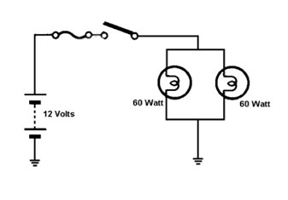

3. State how light is emitted from a conventional bulb. (2 marks)

4. Name TWO different types of headlamp unit used (2 marks)

5. Name TWO different types of bulbs used (2 marks)

6. Draw a simple brake light circuit and state how it operates (14 marks)

I confirm that the work carried out on this knowledge assessment sheet was of the required standard

Assessor Name:

Assessor PIN: Date:

PRACTICAL ASSESSMENT ASSESSOR RECORD:

L114 Vehicle Lighting System Maintenance

LO: | Assessment Criteria
1 | 1.1 Use appropriate PPE when working on vehicle lighting systems  1.2 Use appropriate and safe working practices when working on vehicle lighting systems
2 | 2.1 Identify the main types of bulbs used on modern vehicles  2.2 Identify examples of the types of headlamp units available  2.3 State the colour of lamps that are legally required on a 4 wheeled vehicle
3 | - Demonstrate the ability to accurately read and interpret a simple lighting circuit wiring diagram  - State how light is emitted from a conventional bulb  - State how a brake light circuit operates
4 | 4.1 Demonstrate the correct method to replace a halogen headlamp bulb  - Demonstrate the correct method to replace a headlamp unit  - Demonstrate the correct method to align a headlamp to within legal requirements  - Using a wiring diagram, locate the brake light circuit fuse and check its condition and rating against technical data

The section below is for use by the assessor:
Assessment Outcome: |  |  |  |  |  | Passed (Tick√)
1 | Be able to work safely on vehicle lighting systems
2 | Know vehicle lighting systems components
3 | Know how vehicle lighting systems operate
4 | Be able to replace lighting system components
Assessor Name (Print) |  |  | Tick (√) | Written feedback (with reference to assessment criteria) must be given when a learner is referred:
PASS
I confirm that the learner’s work was to an acceptable standard and met the assessment criteria of the unit
REFER
The work carried out did not achieve the standards specified by the assessment criteria (written feedback to learner)
Assessor Name (Print): |  |  |  |  | Assessor PIN: | Date:
The section below is only to be completed once the assessor decision has been made and feedback given to learner:
The section below is to be completed by the learner:
I confirm that the work carried out was my own, and that I received feedback from the Assessor |  | Learner name (Print): |  |  | Learner Signature: |  | Date:

LEARNER WORK SHEET

Unit No: L115 - ROUTINE MOTORCYCLE MAINTENANCE PROCESSES AND PROCEDURES

Carry out Routine Motorcycle Maintenance

Learner Name: |  |  |  |  |  |  |  | Date work carried out:
Assessment criteria covered: Unit L115 – AC 1.1, 1.2, 2.1, 3.1, 4.1 – 4.5
Motorcycle Details |  |  |  |  |  |  |  |  | Description of work required/customer request:  1. Using an inspection schedule sheet carry out an Interim service  2. Carry out the following checks/adjustments and or lubrication  a. Chains  b. Steering and suspension components  c. Brake and clutch linkages and levers  d. Headlamps  e. Fluid levels  f. Tyre pressures and tread  g. Switches  h. Stands  i. Cables  j. Lubrication points  3. Remove and replace various body panels
Reg No: |  |  |  | VIN/Eng No:
Make:
Model:


Write up of work carried out (continue on separate sheet if required):

PPE worn: |  |  |  |  | Special tools used:
Details of technical data/tightening torques used: |  |  |  |  | Further faults found:
Engine oil capacity:
Tyre pressures:
Tyre tread depth:
I confirm that the work carried out on this data collection sheet was of the required standard |  |  | Assessor Name: |  |  |  | Assessor PIN: |  |  | Date:

PRACTICAL ASSESSMENT ASSESSOR RECORD:

L115 Routine Motorcycle Maintenance Processes & Procedures

LO: | Assessment Criteria
1 | 1.1 Use appropriate PPE when working on motorcycles  1.2 Use appropriate and safe working practices when carrying out routine motorcycle maintenance
2 | 2.1 Identify the main components and systems found on a modern motorcycle or scooter that require maintenance
3 | 3.1 Locate the correct and appropriate sources of information, tools and equipment required to carry out motorcycle maintenance
4 | 4.1. Locate and use the correct technical data when carrying out routine maintenance of motorcycles or scooters  4.2. Demonstrate the correct procedures when removing body panels and seat units prior to carrying out routine motorcycle maintenance.  4.3 Demonstrate the correct procedures when inspecting systems and components during basic motorcycle maintenance e.g. interim service  4.4 Demonstrate the correct procedures when replacing and replenishing fluids and service items during basic motorcycle maintenance  - Demonstrate the correct procedures when adjusting and lubricating motorcycle components and systems

The section below is for use by the assessor:
Assessment Outcome: |  |  |  |  |  | Passed (Tick√)
1 | Be able to work safely when carrying out routine motorcycle maintenance
2 | Know motorcycle components and systems that require maintenance
3 | Know routine maintenance requirements for motorcycles
4 | Be able to carryout routine maintenance on motorcycles e.g. interim service
Assessor Name (Print) |  |  | Tick (√) | Written feedback (with reference to assessment criteria) must be given when a learner is referred:
PASS
I confirm that the learner’s work was to an acceptable standard and met the assessment criteria of the unit
REFER
The work carried out did not achieve the standards specified by the assessment criteria (written feedback to learner)
Assessor Name (Print): |  |  |  |  | Assessor PIN: | Date:
The section below is only to be completed once the assessor decision has been made and feedback given to learner:
The section below is to be completed by the learner:
I confirm that the work carried out was my own, and that I received feedback from the Assessor |  | Learner name (Print): |  |  | Learner Signature: |  | Date:

LEARNER WORK SHEET

Unit No: L116 Task 1
MOTORCYCLE STEERING AND SUSPENSION SYSTEMS COMPONENTS AND MAINTENANCE

Steering System Component Adjustment/Replacement

Learner Name: |  |  |  |  |  |  |  | Date work carried out:
Assessment criteria covered: Unit L116 – AC 1.1, 1.2, 4.1- 4.3
Motorcycle Details |  |  |  |  |  |  |  |  | Description of work required/customer request:  1. Remove and refit a set of handlebars  2. Adjust the front-to-rear wheel alignment to within manufactures tolerance
Reg No: |  |  |  | VIN/Eng No:
Make:
Model:
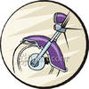

Write up of work carried out (continue on separate sheet if required):

PPE worn: |  |  |  |  | Special tools used:
Details of technical data/tightening torques used: |  |  |  |  | Further faults found:
Wheel Alignment Data:
Tyre Pressures:
Wheel torque setting:
I confirm that the work carried out on this data collection sheet was of the required standard |  |  | Assessor Name: |  |  |  | Assessor PIN: |  |  | Date:

LEARNER WORK SHEET

Unit No: L116 Task 2
MOTORCYCLE STEERING AND SUSPENSION SYSTEMS COMPONENTS AND MAINTENANCE

Suspension System Component Replacement

Learner Name: |  |  |  |  |  |  |  | Date work carried out:
Assessment criteria covered: Unit L116 – AC 1.1,1.2, 5.1 – 5.3
Vehicle Details |  |  |  |  |  |  |  |  | Description of work required/customer request:  1. Check suspension system for leaks and obvious defects  2. Remove and refit a front fork unit.
Reg No: |  |  |  | VIN/Eng No:
Make:
Model:


Write up of work carried out (continue on separate sheet if required):

PPE worn: |  |  |  |  | Special tools used:
Details of technical data/tightening torques used: |  |  |  |  | Further faults found:
Wheel tightening torque data:
Tyre Pressures:
Fork tightening torque data:
I confirm that the work carried out on this data collection sheet was of the required standard |  |  | Assessor Name: |  |  |  | Assessor PIN: |  |  | Date:

Knowledge Assessment Unit L116 Learner Name:

Motorcycle steering systems components and maintenance Assessment criteria covered:
AC 2.1, 2.2 & 3.1

1. State the purpose of the steering components below (10 marks)

a. Top and Bottom Yokes

b. Handlebars

2. Give an over view of what the following terms are and how they affect a motorcycle steering system. (15 marks)

a. Castor Angle

b. Front to Rear Wheel Alignment

c. Steering Head Bearings

I confirm that the work carried out on this knowledge assessment sheet was of the required standard

Assessor Name:

Assessor PIN: Date:

Knowledge Assessment Unit L116 Learner Name:

Suspension system components and maintenance Assessment criteria covered:
AC 2.3, 2.4 & 3.2

3. Identify the following components and state their purpose in a motorcycle suspension system (15 marks)

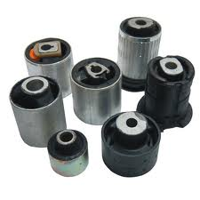
a. b. c.

Component: Component: Component:

Purpose: Purpose: Purpose:

4. Explain the action of the suspension when the motorcycle goes over a bump. (3 marks)

5. Explain the terms bump and rebound in relation to the suspension system (2 marks)

6. Identify the following suspension layout (5 marks)
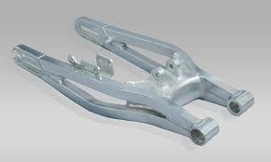

I confirm that the work carried out on this knowledge assessment sheet was of the required standard

Assessor Name:

Assessor PIN: Date:

PRACTICAL ASSESSMENT ASSESSOR RECORD:

L116 Motorcycle Steering and Suspension Systems Components and Maintenance

LO: | Assessment Criteria
1 | 1.1 Use appropriate PPE when working on motorcycle steering and suspension systems  1.2 Use appropriate and safe working practices when working on motorcycle steering and suspension systems
2 | 2.1 Identify the main components used in motorcycle steering systems  2.2 State the purpose of the main components used in motorcycle steering systems  2.3 Identify the main components used in motorcycle suspension systems  2.4 State the purpose of the main components used in motorcycle suspension systems
3 | 3.1 State the operating principles of motorcycle steering systems and components  3.2 State the operating principles of motorcycle suspension systems and components
4 | 4.1 Select the correct technical data for routine maintenance of motorcycle steering systems  4.2 Demonstrate the correct procedures when removing and refitting handlebars  4.3 Demonstrate the correct procedures for adjusting front-to-rear wheel alignment to within manufacturers tolerance
5 | 5.1 Select the correct technical data for routine maintenance of motorcycle suspension systems  5.2 Demonstrate the correct procedures to check motorcycle suspension systems for leaks and visually obvious defects  5.3 Demonstrate the correct procedures when removing and refitting a front fork unit

The section below is for use by the assessor:
Assessment Outcome: |  |  |  |  |  | Passed (Tick√)
1 | Be able to work safely on motorcycle steering and suspension systems
2 | Know about motorcycle steering and suspension components
3 | Know how motorcycle steering and suspension systems operate
4 | Be able to carryout routine maintenance on motorcycle steering systems
5 | Be able to carryout routine maintenance on motorcycle suspension systems
Assessor Name (Print) |  |  | Tick (√) | Written feedback (with reference to assessment criteria) must be given when a learner is referred:
PASS
I confirm that the learner’s work was to an acceptable standard and met the assessment criteria of the unit
REFER
The work carried out did not achieve the standards specified by the assessment criteria (written feedback to learner)
Assessor Name (Print): |  |  |  |  | Assessor PIN: | Date:
The section below is only to be completed once the assessor decision has been made and feedback given to learner:
The section below is to be completed by the learner:
I confirm that the work carried out was my own, and that I received feedback from the Assessor |  | Learner name (Print): |  |  | Learner Signature: |  | Date:

LEARNER WORK SHEET

Unit No: L117 VEHICLE BODY REPAIR PRACTICES

AND PROCEDURES

Carry out Minor Bodywork Repairs

Learner Name: |  |  |  |  |  |  |  | Date work carried out:
Assessment criteria covered: Unit L117 – AC1.1, 1.2, 3.1, 3.2, 4.1 & 4.2
Vehicle Details |  |  |  |  |  |  |  |  | Description of work required/customer request:  1. Carry out a minor dent repair using hammers and dollies.  2. Fill a minor dent using body filler
Reg No: |  |  |  | VIN/Eng No:
Make:
Model:
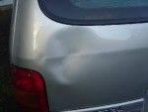

Write up of work carried out (continue on separate sheet if required): |  |  |  |  |  |  |  |  | List the hand tools that could be used for a minor dent repair  1.  2.  3.  4.  5.  6.  7.
PPE worn: |  |  |  |  | Special tools used:
Details of technical data: |  |  |  |  | Further faults found:
Mixing ratio for filler:
Max thickness that can be applied in one go:
Cure time:
I confirm that the work carried out on this data collection sheet was of the required standard |  |  | Assessor Name: |  |  |  | Assessor PIN: |  |  | Date:

Knowledge Assessment Unit L117 Learner Name:

Assessment criteria covered: – AC 2.1, 2.2 & 2.3

1. List SIX different vehicle body types. (18 marks)

1. – 2. –

3. – 4. –

5. – 6. –

2. Name the THREE distinct construction methods for vehicles (9 marks)

1. –

2. –

3. –

3. Give another name for an integral construction that means the same. (3 marks)

4. Identify the following vehicle body components (14 marks)
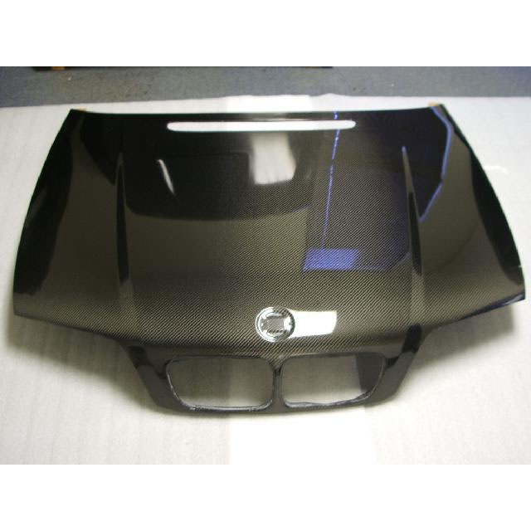
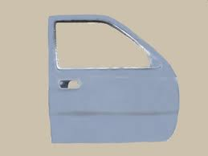
a. b.

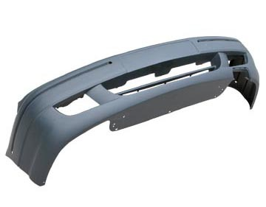
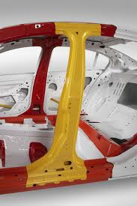
c. d.

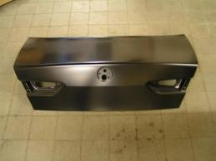
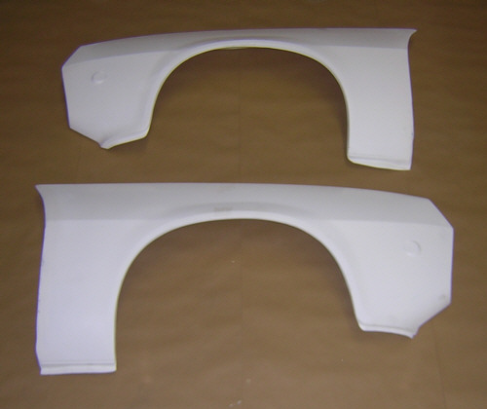
e. f.

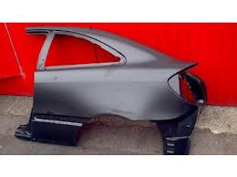
g.

5. Name THREE different materials used for the construction of vehicles (6 marks)

- –

- –

- –

I confirm that the work carried out on this knowledge assessment sheet was of the required standard

Assessor Name:

Assessor PIN: Date:

PRACTICAL ASSESSMENT ASSESSOR RECORD:

L117 Vehicle Body Repair Practices and Procedures

LO: | Assessment Criteria
1 | 1.1 Use appropriate PPE when carrying out minor body repairs  1.2 Use appropriate and safe working practices when carrying out body repair
2 | 2.1 Identify the materials used for vehicle bodywork and bodywork components  2.2 Identify types of vehicle construction  2.3 Identify the main bodywork components
3 | 3.1 Identify the materials used for minor bodywork repairs  - Identify the hand tools and equipment used for minor bodywork repairs
4 | - Demonstrate appropriate use of dollies and hammers for minor dent repairs  - Demonstrate appropriate use of body filler for minor dent repairs

The section below is for use by the assessor:
Assessment Outcome: |  |  |  |  |  | Passed (Tick√)
1 | Be able to work safely when carrying out minor body repairs
2 | Know vehicle bodywork construction and bodywork components
3 | Know materials, tools and equipment used for minor bodywork repairs
4 | Be able to carryout minor bodywork repairs
Assessor Name (Print) |  |  | Tick (√) | Written feedback (with reference to assessment criteria) must be given when a learner is referred:
PASS
I confirm that the learner’s work was to an acceptable standard and met the assessment criteria of the unit
REFER
The work carried out did not achieve the standards specified by the assessment criteria (written feedback to learner)
Assessor Name (Print): |  |  |  |  | Assessor PIN: | Date:
The section below is only to be completed once the assessor decision has been made and feedback given to learner:
The section below is to be completed by the learner:
I confirm that the work carried out was my own, and that I received feedback from the Assessor |  | Learner name (Print): |  |  | Learner Signature: |  | Date:

LEARNER WORK SHEET

Unit No: L118 PREPARATION PRIOR TO PAINT REFINISHING

Prepare fill and flat a panel prior to any refinishing

Learner Name: |  |  |  |  |  |  |  | Date work carried out:
Assessment criteria covered: Unit L118 – AC 1.1, 1.2, 3.1 - 3.5, 4.2, 4.4 & 4.5
Vehicle Details |  |  |  |  |  |  |  |  | Description of work required/customer request:  1. Prepare a vehicle panel which has some minor damage ready for refinishing  2. Mask the vehicle ready for refinishing
Reg No: |  |  |  | VIN/Eng No:
Make:
Model:


Write up of work carried out (continue on separate sheet if required):

PPE worn: |  |  |  |  | PPE worn when paint stripping:
Details of technical data: |  |  |  |  | Further faults found:
Mixing ratio for filler:
Pot life:
Cure time:
I confirm that the work carried out on this data collection sheet was of the required standard |  |  | Assessor Name: |  |  |  | Assessor PIN: |  |  | Date:

Knowledge Assessment Unit L118 Learner Name:

Assessment criteria covered:– AC 2.1, 2.2, 4.1 & 4.3

1. List the technical properties of each of the substrates shown below. In relation to Strength, Corrosion, Painting, Flexibility and Weldability: (25 marks)
.

a. Steel - b. Aluminium

c. Thermoplastic - d. Thermosetting Plastic

e. Coated Steels

2. Name FOUR different types of plastic fillers and stoppers available (16 marks)

1. –

2. –

3. –

4. –

3. Give THREE factors that affect ‘pot-life’ on a 2-pack product (9 marks)

I confirm that the work carried out on this knowledge assessment sheet was of the required standard

Assessor Name:

Assessor PIN: Date:

PRACTICAL ASSESSMENT ASSESSOR RECORD:

L118 Preparation Prior to Paint Refinishing

LO: | Assessment Criteria
1 | - Use appropriate PPE when carrying out vehicle refinishing  - Use appropriate and safe working practices when carrying out vehicle refinishing
2 | 2.1 Identify procedures for identifying different substrates  2.2 Identify the technical properties of substrates
3 | 3.1 Demonstrate the main stages required in preparing a vehicle for refinishing  3.2. Identify the procedures used in preparing different substrates  3.3. Demonstrate the procedures for the preparation and application of chemical solutions and solvents to remove paint  3.4. Demonstrate the procedures to be followed in flatting substrates  3.5. Demonstrate basic masking techniques
4 | 4.1. Identify the types of plastic fillers and stoppers available  4.2. Demonstrate the importance of correct mixing prior to application  4.3. Identify the factors affecting ‘pot-life’  4.4. Demonstrate the methods of application  4.5. Demonstrate the methods of shaping cured filler

The section below is for use by the assessor:
Assessment Outcome: |  |  |  |  |  | Passed (Tick√)
1 | Be able to work safely when carrying out vehicle refinishing
2 | Know the methods of identifying vehicle substrates
3 | Be able to prepare substrates for refinishing
4 | Be able to apply and shape plastic fillers and stoppers
Assessor Name (Print) |  |  | Tick (√) | Written feedback (with reference to assessment criteria) must be given when a learner is referred:
PASS
I confirm that the learner’s work was to an acceptable standard and met the assessment criteria of the unit
REFER
The work carried out did not achieve the standards specified by the assessment criteria (written feedback to learner)
Assessor Name (Print): |  |  |  |  | Assessor PIN: | Date:
The section below is only to be completed once the assessor decision has been made and feedback given to learner:
The section below is to be completed by the learner:
I confirm that the work carried out was my own, and that I received feedback from the Assessor |  | Learner name (Print): |  |  | Learner Signature: |  | Date:

LEARNER WORK SHEET

Unit No: L119 INTRODUCTION TO SPARK IGNITION FUEL SYSTEMS

Spark Ignition Air Filter Change and Leak Check

Learner Name: |  |  |  |  |  |  |  | Date work carried out:
Assessment criteria covered: Unit L119 – AC 1.1, 3.1, 3.2 & 4.1
Vehicle Details |  |  |  |  |  |  |  |  | Description of work required/customer request:  1. Carry out an air filter change  2. Carry out a visual check of the system  for fuel leakage  3. Dispose of the fuel filter correctly
Reg No: |  |  |  | VIN/Eng No:
Make:
Model:
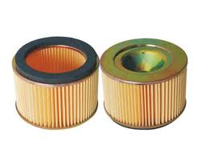

Write up of work carried out (continue on separate sheet if required): |  |  |  |  |  |  |  |  | List FIVE areas/items that need inspecting for fuel leaks  1.  2.  3.  4.  5.
PPE worn: |  |  |  |  | Special tools used:
Details of technical data: |  |  |  |  | Further faults found:
Filter life in miles:

Filter life in years/months:

I confirm that the work carried out on this data collection sheet was of the required standard |  |  | Assessor Name: |  |  |  | Assessor PIN: |  |  | Date:

Knowledge Assessment Unit L119 Learner Name:

Assessment criteria covered:– AC 2.1 & 2.2

1. Identify the parts of the spark ignition fuel system below: (35 marks)

a. b.
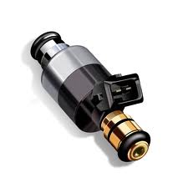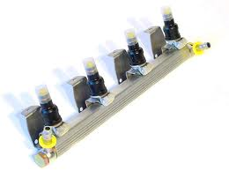

c. c.

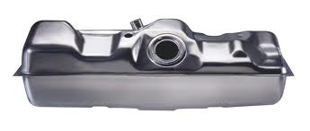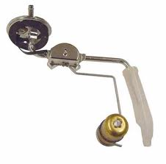

d. e.

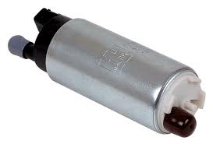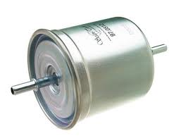

f.
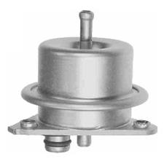

2. State the precautions to be taken when working on spark ignition fuel systems (15 marks)

I confirm that the work carried out on this knowledge assessment sheet was of the required standard

Assessor Name:

Assessor PIN: Date:

PRACTICAL ASSESSMENT ASSESSOR RECORD:

L119 Introduction to Spark Ignition Fuel Systems

LO: | Assessment Criteria
1 | 1.1. Use safe working practices when working on spark ignition fuel systems
2 | 2.1. Identify the major parts of the spark ignition fuel system  2.2. State the precautions to be taken when working on spark ignition fuel systems
3 | 3.1. Change an engine air filter element  3.2. Perform visual check for fuel leakage
4 | 4.1. Demonstrate appropriate ways to dispose of waste products in accordance with environmental guidance

The section below is for use by the assessor:
Assessment Outcome: |  |  |  |  |  | Passed (Tick√)
1 | Be able to work safely
2 | Know the components of spark ignition fuel systems
3 | Be able to change air filters
4 | Be aware of environmental considerations
Assessor Name (Print) |  |  | Tick (√) | Written feedback (with reference to assessment criteria) must be given when a learner is referred:
PASS
I confirm that the learner’s work was to an acceptable standard and met the assessment criteria of the unit
REFER
The work carried out did not achieve the standards specified by the assessment criteria (written feedback to learner)
Assessor Name (Print): |  |  |  |  | Assessor PIN: | Date:
The section below is only to be completed once the assessor decision has been made and feedback given to learner:
The section below is to be completed by the learner:
I confirm that the work carried out was my own, and that I received feedback from the Assessor |  | Learner name (Print): |  |  | Learner Signature: |  | Date:

LEARNER WORK SHEET

Unit No: L120 INTRODUCTION TO COMPRESSION IGNITION FUEL SYSTEMS

Compression Ignition Filter Change and Leak Check

Learner Name: |  |  |  |  |  |  |  | Date work carried out:
Assessment criteria covered: Unit L119 – AC 1.1, 3.1, 3.2, 3.3 & 4.1
Vehicle Details |  |  |  |  |  |  |  |  | Description of work required/customer request:  1. Carry out an air filter change  2. Carry out a diesel fuel filter change  3. Carry out a visual check of the system  for fuel leakage  4. Dispose of the fuel filter correctly
Reg No: |  |  |  | VIN/Eng No:
Make:
Model:
Write up of work carried out (continue on separate sheet if required): |  |  |  |  |  |  |  |  | List FIVE areas/items that need inspecting for fuel leaks  1.  2.  3.  4.  5.
PPE worn: |  |  |  |  | Special tools used:
Details of technical data: |  |  |  |  | Further faults found:
Air Filter life in miles:

Fuel Filter life in years/months:

I confirm that the work carried out on this data collection sheet was of the required standard |  |  | Assessor Name: |  |  |  | Assessor PIN: |  |  | Date:

Knowledge Assessment Unit L120 Learner Name:

Assessment criteria covered:– AC 2.1 & 2.2

1. Identify the parts of the compression ignition fuel system below: (30 marks)

a. b.
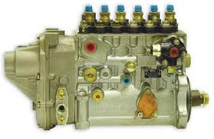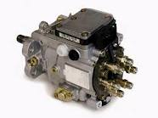

c. d.

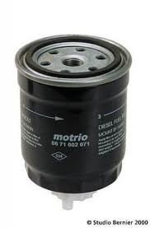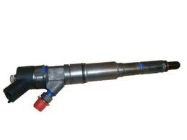

e. f.

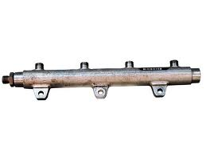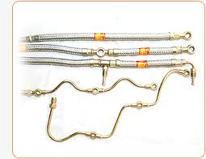

2. State the precautions to be taken when working on compression ignition fuel systems (20 marks)

I confirm that the work carried out on this knowledge assessment sheet was of the required standard

Assessor Name:

Assessor PIN: Date:

PRACTICAL ASSESSMENT ASSESSOR RECORD:

L120 Introduction to Compression Ignition Fuel Systems

LO: | Assessment Criteria
1 | 1.1. Use safe working practices when working on compression ignition fuel systems
2 | 2.1. Identify the major parts of the compression ignition fuel system  2.2. State the precautions to be taken when working on compression ignition fuel systems
3 | 3.1. Change a compression ignition engine air filter element  3.2. Change a compression ignition engine fuel filter  3.3. Perform visual check for fuel leakage
4 | 4.1. Demonstrate appropriate ways to dispose of waste products in accordance with environmental guidance

The section below is for use by the assessor:
Assessment Outcome: |  |  |  |  |  | Passed (Tick√)
1 | Be able to work safely
2 | Know the components of compression ignition fuel systems
3 | Be able to change fuel and air filters
4 | Be aware of environmental considerations
Assessor Name (Print) |  |  | Tick (√) | Written feedback (with reference to assessment criteria) must be given when a learner is referred:
PASS
I confirm that the learner’s work was to an acceptable standard and met the assessment criteria of the unit
REFER
The work carried out did not achieve the standards specified by the assessment criteria (written feedback to learner)
Assessor Name (Print): |  |  |  |  | Assessor PIN: | Date:
The section below is only to be completed once the assessor decision has been made and feedback given to learner:
The section below is to be completed by the learner:
I confirm that the work carried out was my own, and that I received feedback from the Assessor |  | Learner name (Print): |  |  | Learner Signature: |  | Date:

L121 Introduction to Low Carbon Technologies in the Automotive Industry

Knowledge Assessment Unit L121 Learner Name:

Assessment criteria covered: – AC 1.1, 1.2, 2.1 - 2.3, 3.1 – 3.4

1. Give FOUR examples of driving styles that harm the environment: (8 marks)

2. Give FOUR examples how carbon emissions can be reduced when travelling: (8 marks)

3. State FOUR exhaust emissions produced by a conventional vehicle and the impact of each emission on the
environment: (8 marks)

4. State the meaning of carbon footprint: (4 marks)

5. State common vehicle parts that may be recycled: (8 marks)

6. Identify FOUR new types of engine and propulsion methods in current vehicles and those of the near future, and give an example of the benefits to users and the environment: (8 marks)

7. Describe how the use of bio-fuels can reduce carbon emissions (6 marks)

I confirm that the work carried out on this knowledge assessment sheet was of the required standard

Assessor Name:

Assessor PIN: Date:

PRACTICAL ASSESSMENT ASSESSOR RECORD:

L121 Introduction to Low Carbon Technologies in the Automotive Industry

LO: | Assessment Criteria
1 | 1.1. Give examples of driving styles that harm the environment  1.2. Give examples how they can reduce carbon emissions when travelling
2 | 2.1. Identify the exhaust emissions that a conventional vehicle produces  - Describe the impact of exhaust emissions on people and the environment  - State the meaning of ‘carbon footprint’
3 | 3.1. State the common vehicle parts that may be recycled  3.2. Identify the new types of propulsion available in modern and future vehicles  3.3. State the benefits of alternative fuel types and propulsion methods for the user and environment  3.4. Describe how bio-fuels can reduce carbon emissions

The section below is for use by the assessor:
Assessment Outcome: |  |  |  |  |  | Passed (Tick√)
1 | Know how their own actions can affect the environment
2 | Know the impact that a conventional vehicle has on the environment
3 | Know some of the actions vehicle manufacturers are taking to reduce carbon emissions
Assessor Name (Print) |  |  | Tick (√) | Written feedback (with reference to assessment criteria) must be given when a learner is referred:
PASS
I confirm that the learner’s work was to an acceptable standard and met the assessment criteria of the unit
REFER
The work carried out did not achieve the standards specified by the assessment criteria (written feedback to learner)
Assessor Name (Print): |  |  |  |  | Assessor PIN: | Date:
The section below is only to be completed once the assessor decision has been made and feedback given to learner:
The section below is to be completed by the learner:
I confirm that the work carried out was my own, and that I received feedback from the Assessor |  | Learner name (Print): |  |  | Learner Signature: |  | Date:

Knowledge Assessment Unit EL02 Learner Name:

Introduction to the Retail Automotive Maintenance and Repair Industry

Assessment criteria covered:– AC 1.1, 2.1, 3.1 - 3.3

This unit provides learners with an understanding of the various organisations that make up the maintenance and repair sector of the retail motor industry and the various vehicles that the organisations cater for. The unit also introduces learners to the types of job roles available within the sector.

1. AUTOCITY
Instruct the learner to do the following:
- Go to www.autocity.org.uk
- Click on World at Work
- Identify the organisations and then mark them on the Learner Task Sheet EL02 overleaf (This sheet may be laminated and re-used. There is no requirement to keep this once assessed)

2. Online Test

Explain to the learner that they will have 1 hour to complete the EL02 online test, which covers learning outcomes 2 and 3. Inform learners that the questions contain pictures and that these questions are in either, a drag & drop or a multiple-choice format.

(Full guidance regarding this test and IMI Awards online test system can be found in the Qualification Guidance and Assessment Criteria document in Section 1.4b and in the IMI Awards’ Approved Centre Operating Manual in Section 5.2.)

Date; EL02 test passed

I confirm that the work carried out on this knowledge assessment sheet was of the required standard

Assessor Name:

Assessor PIN: Date:

Knowledge Assessment Unit EL02 Learner Name:

3. Using the diagram below and Autocity, identify the NINE main types of organisation that make up the Retail Motor Industry.

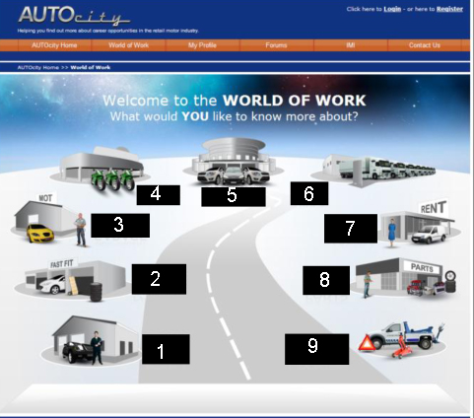

No. | Organisation
1
2
3
4
5
6
7
8
9

PRACTICAL ASSESSMENT ASSESSOR RECORD:

EL02 Introduction to the Retail Automotive Maintenance Repair Industry

LO: | Assessment Criteria
1 | 1.1. Name the types of organisations that make up the maintenance and repair structure of the retail automotive sector.
2 | 2.1. Label the different types of vehicle within the retail automotive sector.
3 | 3.1. State seven technical and non-technical job roles available within the sector.  3.2. Give one example of the type of work carried out for each of the job roles.  3.3. Name the opportunities for career progression and development within the automotive sector.

The section below is for use by the assessor:
Assessment Outcome: |  |  |  |  |  | Passed (Tick√)
1 | Know the type of organisations that make up the retail automotive maintenance and  repair industry
2 | Know the types of vehicle within the sector (Oral Questioning)
3 | Know the technical and non-technical job roles available within the sector (Oral  Questioning)
Assessor Name (Print) |  |  | Tick (√) | Written feedback (with reference to assessment criteria) must be given when a learner is referred:
PASS
I confirm that the learner’s work was to an acceptable standard and met the assessment criteria of the unit
REFER
The work carried out did not achieve the standards specified by the assessment criteria (written feedback to learner)
Assessor Name (Print): |  |  |  |  | Assessor PIN: | Date:
The section below is only to be completed once the assessor decision has been made and feedback given to learner:
The section below is to be completed by the learner:
I confirm that the work carried out was my own, and that I received feedback from the Assessor |  | Learner name (Print): |  |  | Learner Signature: |  | Date:

LEARNER WORK SHEET

Unit No: EL07 PRINCIPLES OF COMPONENT FITTING

Removal and Replacement of Mechanical, Electrical and Trim Components

Learner Name: |  |  |  |  |  |  |  | Date work carried out:
Assessment criteria covered: Unit EL07 – AC 1.1, 2.1, 3.1 & 5.1
Vehicle Details |  |  |  |  |  |  |  |  | Description of work required/customer request:  1. Remove and refit THREE items from each of the groups below:
Reg No: |  |  |  | VIN/Eng No:
Make:
Model:
Group 1

Seat

Front Bumper

Rear Bumper

Bonnet

Group 2  Interior Door Trim  Glove box  Boot/Tailgate  Door Aperture Seals |  |  |  |  |  |  |  |  | Group 3  Battery  Headlight  Rear Light  Alternator
PPE worn: |  |  |  |  | Special tools used:
Details of technical data: |  |  |  |  | Further faults found:
Tightening Torque:

I confirm that the work carried out on this data collection sheet was of the required standard |  |  | Assessor Name: |  |  |  | Assessor PIN: |  |  | Date:

Knowledge Assessment Unit EL07 Learner Name:
Principles of Component Fitting
Assessment criteria covered: – AC 4.1 – 4.3

1. State the correct method to isolate electrical components before removal and refitting (2 marks)

2. State how to select the correct fuse for replacement (2 marks)

3. State the correct methods for disconnecting and reconnecting batteries (6 marks)

I confirm that the work carried out on this knowledge assessment sheet was of the required standard

Assessor Name:

Assessor PIN: Date:

PRACTICAL ASSESSMENT ASSESSOR RECORD:

EL07 Principles of Component Fitting

LO: | Assessment Criteria
1 | 1.1. Use appropriate PPE and safe working practices when removing and refitting body, electrical and trim components
2 | 2.1. Demonstrate the removal and refitting of body components.
3 | 3.1. Demonstrate the removal and refitting of trim components.
4 | 4.1. State the correct methods to isolate electrical components before removal and refitting  4.2. State how to select the correct fuse for replacement  4.3. State the correct methods for disconnecting and reconnecting batteries
5 | 5.1. Demonstrate the removal and refitting of electrical components.

The section below is for use by the assessor:
Assessment Outcome: |  |  |  |  |  | Passed (Tick√)
1 | Be able to work safely
2 | Be able to correctly remove and refit basic body components
3 | Be able to correctly remove and refit basic trim components
4 | Know how to correctly remove and replace simple electrical system components
5 | Be able to correctly remove and refit basic electrical components
Assessor Name (Print) |  |  | Tick (√) | Written feedback (with reference to assessment criteria) must be given when a learner is referred:
PASS
I confirm that the learner’s work was to an acceptable standard and met the assessment criteria of the unit
REFER
The work carried out did not achieve the standards specified by the assessment criteria (written feedback to learner)
Assessor Name (Print): |  |  |  |  | Assessor PIN: | Date:
The section below is only to be completed once the assessor decision has been made and feedback given to learner:
The section below is to be completed by the learner:
I confirm that the work carried out was my own, and that I received feedback from the Assessor |  | Learner name (Print): |  |  | Learner Signature: |  | Date:

LEARNER WORK SHEET

Unit No: EL12 BASIC VEHICLE VALETING

External and Internal Vehicle Valeting

Learner Name: |  |  |  |  |  |  |  | Date work carried out:
Assessment criteria covered: Unit EL12 – AC 3.1 – 3.3
Vehicle Details |  |  |  |  |  |  |  |  | Description of work required/customer request:  Carry out an exterior and interior valet on a motor vehicle
Reg No: |  |  |  | VIN/Eng No:
Make:
Model:
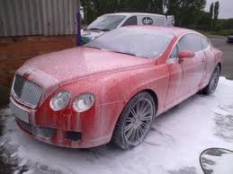

Write up of work carried out (continue on separate sheet if required)

PPE worn: |  |  |  |  | Special tools used:
Details of technical data: |  |  |  |  | Further faults found:
I confirm that the work carried out on this data collection sheet was of the required standard |  |  | Assessor Name: |  |  |  | Assessor PIN: |  |  | Date:

Knowledge Assessment Unit EL12 Learner Name:
Basic Vehicle Valeting
Assessment criteria covered:– AC 1.1 – 1.3 & 2.1 – 2.3

1. Identify SIX pieces of equipment/tools that are used in carrying out an exterior vehicle valet (18 marks)

2. Identify THREE pieces of equipment/tools that are used in carrying out an interior vehicle valet (6 marks)

3. Identify SIX cleaning materials that are used in carrying out an exterior vehicle valet (18 marks)

4. Identify FOUR cleaning materials that are used in carrying out an interior vehicle valet (8 marks)

I confirm that the work carried out on this knowledge assessment sheet was of the required standard

Assessor Name:

Assessor PIN: Date:

PRACTICAL ASSESSMENT ASSESSOR RECORD:

EL12 Basic Vehicle Valeting

LO: | Assessment Criteria
1 | 1.1. Identify the commonly used tools and equipment for valeting a vehicle’s exterior.  1.2. Identify the commonly used tools and equipment for valeting a vehicle’s interior.  1.3. Identify the tasks that are necessary to prepare and use valeting tools safely and correctly.
2 | - Identify the cleaning materials used for valeting a vehicle’s exterior  - Identify the cleaning materials used for valeting a vehicle’s interior  - Identify the tasks and precautions for correctly using cleaning materials.
3 | 3.1. Identify personal protection equipment (PPE) and safe valeting procedures.  3.2. Demonstrate the correct sequence and procedure for valeting a vehicle’s exterior.  3.3. Demonstrate the correct sequence and procedure for valeting a vehicle’s interior.

The section below is for use by the assessor:
Assessment Outcome: |  |  |  |  |  | Passed (Tick√)
1 | Know commonly used valeting tools and equipment and how they are used correctly and safely
2 | Know the commonly used cleaning materials and how they are used correctly and safely
3 | Be able to demonstrate the correct procedures for valeting motor vehicles safely and effectively
Assessor Name (Print) |  |  | Tick (√) | Written feedback (with reference to assessment criteria) must be given when a learner is referred:
PASS
I confirm that the learner’s work was to an acceptable standard and met the assessment criteria of the unit
REFER
The work carried out did not achieve the standards specified by the assessment criteria (written feedback to learner)
Assessor Name (Print): |  |  |  |  | Assessor PIN: | Date:
The section below is only to be completed once the assessor decision has been made and feedback given to learner:
The section below is to be completed by the learner:
I confirm that the work carried out was my own, and that I received feedback from the Assessor |  | Learner name (Print): |  |  | Learner Signature: |  | Date:

LEARNER WORK SHEET

Unit No: EL13 LIGHT VEHICLE CONSTRUCTION

Identification of Vehicle Engine, Drive Line and Body layouts

Learner Name: |  |  |  |  |  |  |  | Date work carried out:
Assessment criteria covered: Unit EL13 – AC 1.1, 1.2 & 2.1
Vehicle Details |  |  |  |  |  |  |  |  | Description of work required/customer request:  Ask the learner to identify the range of layouts listed below.
Reg No: |  |  |  | VIN/Eng No:
Make:
Model:
Ask the learner to identify the body types for a range of vehicles:

Saloon

Coupe

Hatchback

MPV

Convertible

Estate

Ask the learner to identify engine arrangements for a range of vehicles:  Front Engine  Rear Engine  Mid Engine |  |  |  |  |  |  |  |  | Ask the learner to identify driveline configurations for a range of vehicles:  FWD  RWD  4 Wheel Drive
PPE worn: |  |  |  |  | Special tools used:
Details of technical data: |  |  |  |  | Further faults found:
I confirm that the work carried out on this data collection sheet was of the required standard |  |  | Assessor Name: |  |  |  | Assessor PIN: |  |  | Date:

Knowledge Assessment Unit EL13 Learner Name:
Light Vehicle Construction
Assessment criteria covered:– AC 3.1 & 3.2

1. State the name of FOUR non-structural body panels found on a light vehicle (20 marks)

2. State the name of SIX trim components found on a light vehicle (30 marks)

I confirm that the work carried out on this knowledge assessment sheet was of the required standard

Assessor Name:

Assessor PIN: Date:

PRACTICAL ASSESSMENT ASSESSOR RECORD:

EL13 Light Vehicle Construction

LO: | Assessment Criteria
1 | 1.1. Identify the engine arrangements found in a range of light vehicles  1.2. Identify the drive line configurations for a range of vehicles
2 | 2.1. Identify the body types for a range of vehicles
3 | 3.1. State the names of the basic non-structural body panels found on light vehicles  3.2. State the names of the main trim components found on light vehicles

The section below is for use by the assessor:
Assessment Outcome: |  |  |  |  |  | Passed (Tick√)
1 | Know about vehicle layouts and drive line configurations
2 | Know about body types for a range of vehicles
3 | Know the names of the main body parts found on light vehicles
Assessor Name (Print) |  |  | Tick (√) | Written feedback (with reference to assessment criteria) must be given when a learner is referred:
PASS
I confirm that the learner’s work was to an acceptable standard and met the assessment criteria of the unit
REFER
The work carried out did not achieve the standards specified by the assessment criteria (written feedback to learner)
Assessor Name (Print): |  |  |  |  | Assessor PIN: | Date:
The section below is only to be completed once the assessor decision has been made and feedback given to learner:
The section below is to be completed by the learner:
I confirm that the work carried out was my own, and that I received feedback from the Assessor |  | Learner name (Print): |  |  | Learner Signature: |  | Date:

LEARNER WORK SHEET

Unit No: EL14 MOTORCYCLE CONSTRUCTION

Identification of Motorcycle types and components

Learner Name: |  |  |  |  |  |  |  | Date work carried out:
Assessment criteria covered: Unit EL14 – AC 1.1, 2.2 & 3.1
Vehicle Details |  |  |  |  |  |  |  |  | Description of work required/customer request:  1. Identify a range of motorcycle types and their components listed below.
Reg No: |  |  |  | VIN/Eng No:
Make:
Model:
a.Ask the learner to identify a range of motorcycle types:

Scooter Moto Cross

Moped Super Moto

Sports Trials

Tourer

b. Ask the learner to identify the various controls found on a motorcycle:  Front brake lever Side/headlight switch  Rear brake lever Dip switch  Gear change lever Indicator switch  Clutch Engine kill switch  Throttle Ignition switch (and positions) |  |  |  |  |  |  |  |  | c. Ask the learner to identify the main panels found on a faired motorcycle:  Top fairing  Lower fairing  Belly pan  Screen  Tail unit
PPE worn: |  |  |  |  | Special tools used:
Details of technical data: |  |  |  |  | Knowledge check:
I confirm that the work carried out on this data collection sheet was of the required standard |  |  | Assessor Name: |  |  |  | Assessor PIN: |  |  | Date:

Knowledge Assessment Learner Name:

Assessment criteria covered: Unit EL14 – AC 2.1

1. State the names of the main parts found on motorcycles shown below

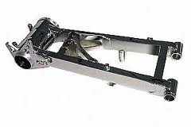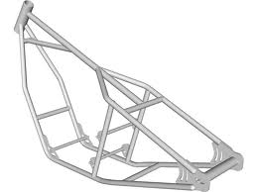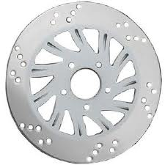

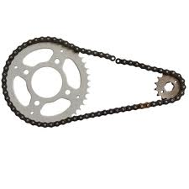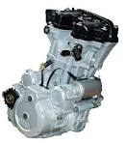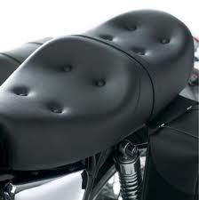

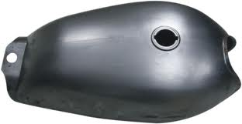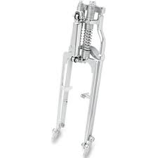

I confirm that the work carried out on this knowledge assessment sheet was of the required standard

Assessor Name:

Assessor PIN: Date:

PRACTICAL ASSESSMENT ASSESSOR RECORD:

EL14 Motorcycle Construction

LO: | Assessment Criteria
1 | 1.1. Identify a range of motorcycle types
2 | 2.1. State the names of the main parts found on naked motorcycles  2.2. State the names of the main panels found on faired motorcycles
3 | 3.1. Identify the position of the various controls found on a range of motorcycles

The section below is for use by the assessor:
Assessment Outcome: |  |  |  |  |  | Passed (Tick√)
1 | Know about the types of motorcycle available
2 | Know the names of the main parts found on motorcycles
3 | Know the position of the controls on scooter and conventional motorcycles
Assessor Name (Print) |  |  | Tick (√) | Written feedback (with reference to assessment criteria) must be given when a learner is referred:
PASS
I confirm that the learner’s work was to an acceptable standard and met the assessment criteria of the unit
REFER
The work carried out did not achieve the standards specified by the assessment criteria (written feedback to learner)
Assessor Name (Print): |  |  |  |  | Assessor PIN: | Date:
The section below is only to be completed once the assessor decision has been made and feedback given to learner:
The section below is to be completed by the learner:
I confirm that the work carried out was my own, and that I received feedback from the Assessor |  | Learner name (Print): |  |  | Learner Signature: |  | Date:

LEARNER WORK SHEET

Unit No: EL16 SIMPLE PAINT SPRAYING PROCESSES

Carry Out the Preparation and Painting of a Small Area

Learner Name: |  |  |  |  |  |  |  | Date work carried out:
Assessment criteria covered: Unit EL16 – AC 1.1, 4.1, 5.1 & 6.1
Vehicle Details |  |  |  |  |  |  |  |  | Description of work required/customer request:  1. Carry out a simple panel preparation process on a pre-painted surface  2. Carry out basic application of waterborne base coat on the prepared surface
Reg No: |  |  |  | VIN/Eng No:
Make:
Model:
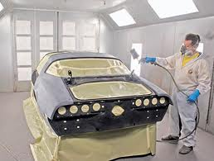
Write up of work carried out (continue on separate sheet if required): |  |  |  |  |  |  |  |  | Name the PPE required for vehicle spraying
PPE worn: |  |  |  |  | Special tools used:
Details of technical data: |  |  |  |  | Further faults found:
Spraying pressure

Paint mixing ratio

I confirm that the work carried out on this data collection sheet was of the required standard |  |  | Assessor Name: |  |  |  | Assessor PIN: |  |  | Date:

Knowledge Assessment Learner Name:

Assessment criteria covered: Unit EL16 – AC 2.1 & 3.1

1. Identify the basic components of the HVLP spray gun below from the following list trigger, fan adjuster valve, pressure adjuster valve, air cap, pressure gauge and volume control screw (18 marks)

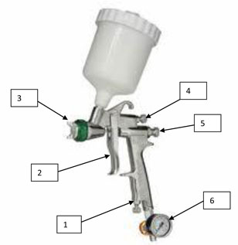

2. State EIGHT pieces of equipment used in vehicle paint spraying (32 marks)

I confirm that the work carried out on this knowledge assessment sheet was of the required standard

Assessor Name:

Assessor PIN: Date:

PRACTICAL ASSESSMENT ASSESSOR RECORD:

EL16: SIMPLE PAINT SPRAYING PROCESSES

LO: | Assessment Criteria
1 | 1.1. Use appropriate safe working practices when spraying paint
2 | 2.1. Label the basic components of a HVLP spray gun
3 | 3.1. State the basic equipment used in vehicle paint spraying
4 | 4.1. Name the required PPE for vehicle paint spraying
5 | 5.1. Demonstrate the appropriate sequences and procedures to carry out simple panel preparation processes on a pre-painted surface
6 | 6.1. Demonstrate the appropriate sequences and procedures to carry out basic application of water borne base coat on prepared surfaces

The section below is for use by the assessor:
Assessment Outcome: |  |  |  |  |  | Passed (Tick√)
1 | Be able to work safely
2 | Know the basic components of a HVLP spray gun
3 | Know the basic equipment used in vehicle paint spraying.
4 | Know the required PPE used in vehicle paint spraying.
5 | Be able to carry out simple panel preparation processes on pre-painted surface
6 | Be able to carry out basic application of waterborne base coat on prepared surfaces
Assessor Name (Print) |  |  | Tick (√) | Written feedback (with reference to assessment criteria) must be given when a learner is referred:
PASS
I confirm that the learner’s work was to an acceptable standard and met the assessment criteria of the unit
REFER
The work carried out did not achieve the standards specified by the assessment criteria (written feedback to learner)
Assessor Name (Print): |  |  |  |  | Assessor PIN: | Date:
The section below is only to be completed once the assessor decision has been made and feedback given to learner:
The section below is to be completed by the learner:
I confirm that the work carried out was my own, and that I received feedback from the Assessor |  | Learner name (Print): |  |  | Learner Signature: |  | Date:

For tutor and assessor use only

LEARNER WORK SHEET

Unit No: L101
HEALTH AND SAFETY PRACTICES IN VEHICLE MAINTENANCE

Workshop Safety Inspection
Learner Name: |  |  |  | Date work carried out:
Assessment criteria covered: AC 1.2,1.4, 2.1, 2.2, 2.3, 3.1, 3.2, 3.3, 4.1, 4.2, 5.2, 5.3
1. Locate the following, and mark on a plan of your workshop:
- health and safety notices
- fire and emergency exits
- first aid box
- fire fighting equipment (including type of extinguisher)
- exhaust extraction points
- potential hazards e.g. ramps and other equipment, trailing cables, flammable storage area
2. Demonstrate the correct lifting methods using manual handling and lifting equipment
State type of equipment used: |  | Mobile crane hoist for lifting engines  Lifting a heavy assembly  (or any other suitable lifting exercise)
3. List SIX materials hazardous to health commonly found in vehicle workshops
1. Waste engine oil |  |  | 4. Vehicle batteries
2. Brake Fluid |  |  | 5. Coolant
3. Petrol |  |  | 6. Grease (or any other suitable answers)
4. Demonstrate the correct procedures to dispose of spilt liquids, metal components/swarf, and used gas cylinders/aerosols and state the PPE worn for each:
Liquid- coolant | State local arrangements |  | Metal / swarf |  | State local arrangements
Liquid- battery acid | State local arrangements |  | Gas cylinder/aerosol |  | State local arrangements
5. State where to go and what to do in the event of and emergency and evacuation:

List the local arrangements

6. Using your workshop as an example, state FOUR hazards that may commonly be found in vehicle workshops and what has been done to reduce the risks to those working in these areas.
1. Spillages (slipping) – Contain, clean and dispose of waste material |  |  | 3. Exhaust fumes – good ventilation and extraction systems
2. Trailing wires (tripping) – tidy equipment away and general good housekeeping practices |  |  | 4. Electric Shock – ensure all items are in good working order (PAT tested where necessary)  (or any other suitable answers)
I confirm that the work carried out on this data collection sheet was of the required standard | Assessor Name: |  | Assessor PIN: |  | Date:

Use of Tools and Equipment

LEARNER WORK SHEET

Unit No: L102
TOOLS, EQUIPMENT AND MATERIALS FOR VEHICLE MAINTENANCE
Learner Name: |  |  |  | Date work carried out:
Assessment criteria covered: AC 1.1,1.2, 1.3, 2.1, 2.3, 2.3, 3.1, 3.2, 3.3, 4.1, 4.2, 4.3
1. Inspect a selection of tools and equipment for damage and note defects found (Minimum of 5 types):
Screwdrivers | Damaged blade or handle |  | Air tools and airlines |  | split pipes, damaged connections
Hammers | Loose head or split handle |  | Electrical equipment |  | Frayed or split cables, damaged insulation or plug
Chisels | Mushroomed head or damaged blade |  | Hydraulic jacks |  | Leaks or creeping  (or any other suitable answers)
2. List the PPE required when working with:
Hot objects e.g. welding | Leather gloves, welding mask, apron, boots |  | Used oil |  | Barrier cream, gloves, overalls, boots.
Sanders and grinders | Goggles, mask, overalls, boots, extraction |  | Battery acid |  | Rubber gloves, apron, overalls, boots
Normal vehicle repairs | Gloves, boots & overalls. |  | Spraying/Painting |  | Mask/ breathing apparatus, gloves, overalls, boots.
3. Use a range of tools and equipment during vehicle maintenance (Minimum of 5 types). State the jobs they were used for:
Hand tools | Normal vehicle repairs, manufacture |  | Hydraulic equipment |  | Vehicle jacks for raising vehicles
Measuring equipment | Brake disc run-out, brake lining thickness |  | Air tools |  | Removing road wheels
Electrical equipment | Measure battery voltage, voltage drop, current flow |  | Mechanical equipment |  | Vehicle lifts – raising vehicles  (or any other suitable answers)
4. Use FOUR of the following materials when carrying out vehicle maintenance. State where they were used:
Oil |  | Lubrication system | Adhesive |  | Interior trim
Grease |  | Wheel bearings | Sealers |  | Exhaust paste
Aerosol |  | Penetrating oil to free off nuts and bolts | Cleaner |  | Brake dust  (or any other suitable answers)
5. State SIX types of materials used in vehicle construction and where they are used:
1. Glass - windscreens |  |  | 4. Plastic - Trim
2. Rubber - tyres |  |  | 5. Leather - Upholstery
3. Steel – body panels |  |  | 6. Wood – Dashboard  (or any other suitable answers)
I confirm that the work carried out on this data collection sheet was of the required standard |  | Assessor Name: | Assessor PIN: |  |  | Date:

UNIT REF: L103 | SI ENGINE SYSTEMS, COMPONENTS AND OPERATION  SAMPLE SOLUTIONS AND MARKING SCHEME

Question  Number | Sample solutions | Total | Assessment  Criteria
1 | a. Cylinder Head – Closes the top of the cylinder off creating the combustion chamber, houses the inlet and exhaust valves and the valve operating mechanism  b. Camshaft – Opens the inlet and exhaust valves  c. Crankshaft – Converts reciprocation action into rotary motion  d. Inlet Valves – Allows the air/fuel mixture into the cylinder  e. Piston – Transfer force from expanding gases to the crankshaft via the con-rod or compress the air/fuel mixture in the cylinder  f. Piston Rings – Create a gas tight seal in the cylinder  g. Connecting Rod – Connects the piston to the crankshaft  h. Valve Spring – Closes the inlet and exhaust valves  2 marks each | 16 | AC2.1  AC2.2
2 | a. Cooling system – To transfer the heat produced from the combustion process and keep the engine at the optimum operating temperature  b. Lubrication system – To reduce friction, wear and corrosion. It also assists in cooling and it keeps moving parts clean  c. Fuel system – To produce the correct air/fuel ratio to run the engine under all operating conditions  d. Ignition system – To produce a spark of sufficient power to ignite the compressed air/fuel mixture at the correct time  2 marks each | 8 | AC2.3
3 | Induction, compression, power and exhaust  1 mark each | 4 | AC3.1
4 | Peugeot 405 1.9 petrol engine:  Inlet valve opens 3ºBTDC  Inlet valve closes 46ºABDC  Exhaust valve opens 40ºBBDC  Exhaust valve closes 2ºATDC  Ignition timing 5ºBTDC at 900rpm  2 marks each | 10 | AC3.3
5 | a. Cold Start – 8:1  b. Idling – 14.7:1  c. Hard Acceleration – 12:1  d. Overrun – No fuel  1 mark each | 4 | AC3.4
6 | 1. Carbon monoxide (CO) – Colourless, odourless gas, poisonous to animal life (highly toxic)  2. Carbon Dioxide (CO₂) – Greenhouse gas that contributes to global warming  3. Hydrocarbons (HC) – Causes respiratory problems, liver damage and cancers  4. Oxides of Nitrogen (NO_{X}) – can cause respiratory conditions, smog and acid rain  2 marks each | 8 | AC3.4
 | Total | 50

UNIT REF:  L104 | CI ENGINE SYSTEMS, COMPONENTS AND OPERATION  SAMPLE SOLUTIONS AND MARKING SCHEME

Question  Number | Sample solutions | Total | Assessment  Criteria
1 | Cylinder Head – Closes the top of the cylinder off creating the combustion chamber, houses the inlet and exhaust valves and the valve operating mechanism  Camshaft – Opens the inlet and exhaust valves  Crankshaft – Converts reciprocation action into rotary motion  Inlet Valves – Allows the air into the cylinder  Piston – Transfer force from expanding gases to the crankshaft via the con-rod or compress the air/fuel mixture in the cylinder  Piston Rings – Create a gas tight seal in the cylinder  Connecting Rod – Connects the piston to the crankshaft  Valve Springs – Closes the inlet and exhaust valves  2 marks each | 16 | AC2.1  AC2.2
2 | Cooling system – To transfer the heat produced from the combustion process and keep the engine at the optimum operating temperature  Lubrication system – To reduce friction, wear and corrosion. It also assists in cooling and it keeps moving parts clean  Fuel system – To produce the correct air/fuel ratio to run the engine under all operating conditions  Air induction system – To clean the air prior to entering the cylinder to prevent damage  2 marks each | 8 | AC2.3
3 | Induction, compression, power and exhaust  1 mark each | 4 | AC3.1
4 | Inlet valve opens 3ºBTDC  Inlet valve closes 46ºABDC  Exhaust valve opens 40ºBBDC  Exhaust valve closes 2ºATDC  2 marks each | 8 | AC3.2
5 | Only air is drawn into the cylinder of a CI engine where both Fuel and air are drawn into the cylinder on a SI engine | 1 | AC1.3
6 | Fuel is injected into the cylinder | 1 | AC3.3
7 | Carbon monoxide (CO) – Colourless, odourless gas, poisonous to animal life (highly toxic)  Carbon Dioxide (CO₂) – Greenhouse gas that contributes to global warming  Hydrocarbons (HC) – Causes respiratory problems, liver damage and cancers  Oxides of Nitrogen (NO_{X}) – can cause respiratory conditions, smog and acid rain  Particulates (soot) – causes respiratory problems and cancers  2 marks each | 10 | AC3.4
8 | Heavier, stronger components and higher compression ratios  1 mark each (max 2) | 2 | AC3.3
 | Total | 50

UNIT REF:  L105 | ENGINE LIQUID COOLING AND LUBRICATION SYSTEMS,  COMPONENTS AND OPERATION  SAMPLE SOLUTIONS AND MARKING SCHEME

Question  Number | Sample solutions | Total | Assessment  Criteria
 | L105 – Liquid Cooling Systems
1 | Radiator – Allows heat to pass to the atmosphere from the coolant  Thermostat – Allows coolant to heat up quickly and then be kept at a constant temperature  Water pump – Circulates the coolant  Hoses – Allows the flexible connection of major cooling system components (i.e engine to radiator)  Fan – Increases the air flow over the radiator and/or engine  Expansion Tank – A sealed container where coolant is forced into as it expands. When the engine cools down coolant flows back from the expansion tank into the cooling system  Antifreeze – An additive to water to prevent it from freezing, it can also help inhibit corrosion  Heater Matrix – Part of the in car heating system which allows warm air to forced into the passenger compartment  2 marks each | 16 | AC2.1  AC2.2
2 | When the engine is cold the thermostat is closed and the coolant is circulated around the engine only. The heat from the combustion process is passed into the coolant and this warmer coolant is now circulated. Keeping the thermostat closed allows a quicker warm up period of the engine. When the coolant temperature reaches the thermostat opening temperature then the thermostat opens allowing coolant to flow to the radiator. As the coolant passes through the radiator the air passing over the radiator transfers the heat from the coolant to the atmosphere allowing the coolant to lower its temperature before being re-circulated around the engine by the water pump. The thermostat will open and close as required to keep the engine at its optimum operating temperature. | 9 | AC3.1
 | L105 Lubrication Systems
3 | a. Oil – Lubricant used in the engine to reduce friction and wear  b. Pressure gauge – A visual instrument to inform the driver of the oil pressure within the engine  c. Oil pump – Distributes oil around the engine  d. Oil cooler – Allows heat to be transferred from the oil to the atmosphere (similar to a coolant radiator)  e. Oil filter – Used to clean the oil  f. Engine breather – A device to prevent the buildup of pressure in the engine interior or crankcase  g. Sump – A large storage area for the oil when the engine is switched off. Situated at the bottom of the engine  h. Pressure relief valve – A valve used to control the maximum oil pressure.  2 marks each | 16 | AC2.3  AC2.4
4 | The operating principles of the lubrication system are:  - Lubricate moving parts to reduce friction and reduce wear  - Cool internal engine components  - Protect the engine from corrosion | 9 | AC3.2
 | Total | 50

UNIT REF:  L106 | STEERING AND SUSPENSION SYSTEMS,  COMPONENTS AND MAINTENANCE  SAMPLE SOLUTIONS AND MARKING SCHEME

Question  Number | Sample solutions |  | Total | Assessment  Criteria
 | L106 Steering Systems
1 | Steering column – The shaft connecting the steering wheel and steering rack or steering box  Steering gearbox – Changes the rotary motion of the steering wheel into the side to side movement at the road wheels  Ball joints – Allows flexible steering movement  Steering joints and couplings – Allows the flexible connection of major steering system components (i.e steering column to steering rack pinion)  Rubber gaiters – To prevent the ingress of dirt and moisture to essential steering components.  Track Rod – A rod that connects the left and right steered wheels  2 marks each |  | 12 | AC2.1  AC2.2
2 | a. Camber Angle –  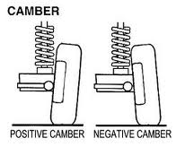  Easier steering, less turning effortless stress on steering components. 3 marks | b. Castor Angle –  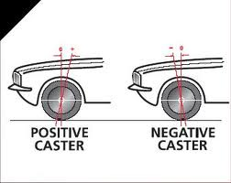  Provides a degree of self centring. 3 marks | 12 | AC3.1
2 | c. Ackermann’s Angle –  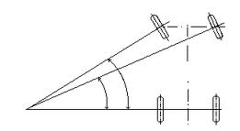  Allows both front wheels to turn corners  with true rolling motion  3 marks | d. SAI/ KPI –  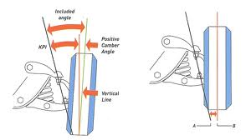  Lighter steering, Improved control on corners, self centre action  3 marks | 12 | AC3.1

Question  Number | Sample solutions |  | Total | Assessment  Criteria
 | L106 Suspension systems
3 | a. Leaf Spring –  Provides control for all driving conditions and general movement; also locates the axle  3 marks | b. Torsion Bar –  Provides springing effect as it is twisted  3 marks | 12 | AC2.3  AC2.4  AC3.1
3 | c. Coil Spring –  Absorb road shocks  3 marks | d. Suspension Damper –  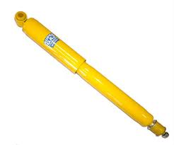  Reduce road spring oscillations  3 marks | 12 | AC2.3  AC2.4  AC3.1
4 | IFS – Independent Front Suspension |  | 3 | AC3.1
5 | IRS – Independent Rear Suspension |  | 3 | AC3.1
6 | Beam Axle |  | 4 | AC2.3
7 | Independent suspension |  | 4 | AC2.3
 | Total |  | 50

UNIT REF:  L107 | VEHICLE BRAKING SYSTEMS COMPONENTS AND MAINTENANCE  SAMPLE SOLUTIONS AND MARKING SCHEME

Question  Number | Sample solutions | Total | Assessment  Criteria
1 | Kinetic energy – The energy of motion | 2 | AC3.2
2 | Coefficient of friction – The resistance encountered by one object moving over another | 2 | AC3.2
3 | Drum brakes – Self servo action, easier to accommodate the parking brake mechanism.  2 marks each (max 4) | 4 | AC2.1  AC3.1
4 | Disc brakes – Better heat dissipation, easier to maintain, cheaper to manufacture, less complex arrangement, cleaner braking surfaces, equal braking going forwards or backwards  2 marks each (max 4) | 4 | AC2.1  AC3.1
5 | The flexible rubber seal on the piston returns to its original shape after the brakes are released which retracts the brake pads | 2 | AC3.2
6 | Moderate braking – Front 60% Rear 40% | 2 | AC3.1
7 | Brake fluid should be changed every 2 years however this may differ between manufacturers. Always follow manufacturer’s recommendations | 2 | AC3.2
8 | a. Master cylinder – Attached to the brake pedal and when the pedal is pressed the master cylinder forces the brake fluid through the pipes  b. Wheel cylinder – Hydraulic fluid acts on pistons within the wheel cylinder to apply force to the brake shoes or pads.  c. Brake calliper – Houses the pistons and brake pads  d. Pressure regulating valve – Controls the pressure between the front and rear brakes  e. Brake servo – Increases the force applied by the driver on the brake pedal  4 marks each | 20 | AC2.2  AC3.2
9 | 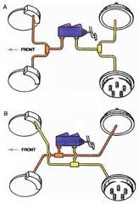  6 marks each diagram | 12 | AC2.1  AC2.2
 | Total | 50

UNIT REF:  L109 | VEHICLE WHEELS AND TYRES CONSTRUCTION AND MAINTENANCE  SAMPLE SOLUTIONS AND MARKING SCHEME

Question  Number | Sample solutions |  | Total | Assessment  Criteria
1 | 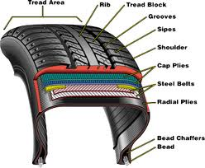  Radial ply |  | 10 | AC2.1  AC2.2
2 | 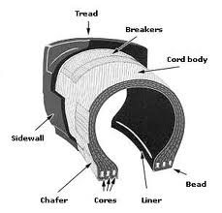  Cross ply |  | 10 | AC2.1  AC2.2
3 | Alloy wheel  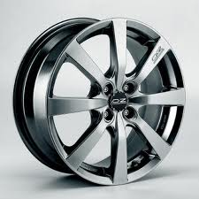  5 marks | Steel wheel  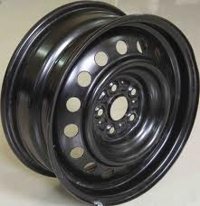  5 marks | 20 | AC2.3
 | Wire spoke wheel  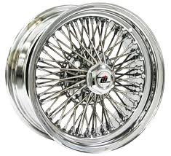  5 marks | Split rim wheel  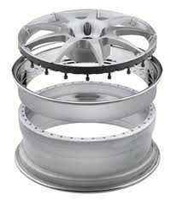  5 marks |  | AC2.3

Question  Number | Sample solutions | Total | Assessment  Criteria
4 | a. 185 – Nominal width in mm  b. 70 – Aspect ratio (70% of the nominal width)  c. 14 – Wheel rim diameter in inches  d. 78 – Load index (425 kg)  e. H – Speed rating (210 kph)  2 marks each | 10 | AC3.1
 | Total | 50

UNIT REF:  L110 | VEHICLE EXHAUST SYSTEMS COMPONENTS AND MAINTENANCE  SAMPLE SOLUTIONS AND MARKING SCHEME

Question  Number | Sample solutions | Total | Assessment  Criteria
1 | 1 – Exhaust manifold  2 – Exhaust system joints and gaskets  3 – Front pipe  4 – Catalytic convertor  5 – Silencer  6 – Heat shield  7 – Exhaust system brackets  4 marks each plus 2 extra marks for getting all correct | 30 | AC1.2
2 | a. Exhaust manifold – Connects the exhaust ports on the engine to the exhaust pipe  b. Lambda sensor – Measure the oxygen content in the exhaust gases  c. Silencer box – Reduce the exhaust gas noises  d. Expansion box – Slows down the exhaust gas flow  e. Catalytic convertor – Reduce the amount of harmful gases entering the atmosphere  f. Exhaust system brackets – To secure the exhaust system to the vehicle with some flexibility  3 marks each plus 2 extra marks for getting all correct | 20 | AC2.3
 | Total | 50

UNIT REF:  L111 | VEHICLE DRIVELINE MAINTENANCE  SAMPLE SOLUTIONS AND MARKING SCHEME

Question  Number | Sample solutions | Total | Assessment  Criteria
1 | a. – Friction Plate/ Driven plate  b. – Pressure plate  c. – Gearbox casing  d. – Gear selector rod and fork  e. – Release bearing/ Thrust bearing  f. – Gear train assembly  3 marks each | 18 | AC3.2
2 | a. – Epicyclic gear set  b. – Solenoids and control valve assembly  c. – Overdrive clutch pack Or brake bands  d. – Torque convertor  5 marks each | 20 | AC3.3
3 | 1 – Provide a range of forward gears  2 – Provide a reverse gear  3 – Provide a permanent neutral  4 – Act as a torque multiplier  3 marks each | 12 | AC3.1
 | Total | 50

UNIT REF:  L112 | SPARK IGNITION SYSTEM MAINTENANCE  SAMPLE SOLUTIONS AND MARKING SCHEME

Question  Number | Sample solutions | Total | Assessment  Criteria
1 | a. – Spark plug  b. – Coil pack  c. – High tension (HT) lead  d. – Electronic Control Unit (ECU)  e. – Electrical cable and connections – used for Light Tension (LT) connections  4 marks each | 20 | AC2.1  AC2.2
2 | a. Ignition coil – Transforms the low voltage from the battery into the high voltage required at the spak plugs  b. HT Leads – Highly insulated wires used to transfer the high voltage from the coil to the distributor and from the distributor to the spark plugs (alternatively on more modern vehicles – from the coil pack to the spark plugs)  c. Spark plugs – Produces the spark in the combustion chamber by making the high voltage jump across a gap in its electrodes  d. ECU – Controls the fuel and ignition system  e. LT leads – Low voltage connections to and from the ignition coil  6 marks each | 30 | AC2.3
 | Total | 50

UNIT REF:  L113 | VEHICLE ELECTRICAL FOUNDATION SKILLS  SAMPLE SOLUTIONS AND MARKING SCHEME

Question  Number | Sample solutions | Total | Assessment  Criteria
1 | Voltage - Volts (V)  Current - Amps (A)  Resistance – Ohms (Ω)  Power – Watts (W)  5 marks each | 20 | AC2.3
2 | a – Battery  b – Switch  c – Motor  d – Fuse  e– Lamp  f – Earth  g– Diode  h – Transistor  i– Relay  3 marks each plus 3 marks for getting all correct | 30 | AC2.4
 | Total | 50

UNIT REF:  L114 | VEHICLE LIGHTING SYSTEM MAINTENANCE  SAMPLE SOLUTIONS AND MARKING SCHEME

Question  Number | Sample solutions | Total | Assessment  Criteria
1 | - White  - Orange  - Red  - Red  - White  - White  - Red  - White  2 marks each | 16 | AC2.3
2 | Label the following: Earth, battery, fuse, switch and bulbs:  2 marks each  Operation – When the switch is closed current can pass through the fuse then the switch and to both bulbs. The current passes through the bulbs to earth completing the circuit and illuminating the bulbs  4 marks | 14 | AC3.1
3 | Light is emitted by converting electrical energy into heat energy | 2 | AC2.2
4 | 2 from below or any other suitable answer  Standard Halogen  Standard Xenon  Bi Xenon  1 mark each (max 2 marks) | 2 | AC2.2
5 | 2 from below or any other suitable answer:  Single filament bayonet cap  Capless bulb  Festoon  Double filament offset bayonet cap  Halogen bulb  1 mark each (max 2 marks) | 2 | AC2.1
6 | Circuit to include: Earth, battery, fuse, brake light switch and brake light bulbs  2 marks each  Operation: When the brake pedal is depressed it closes the brake light switch which allows current to pass through the fuse and switch and on to the brake lights bulbs. The current passes through the bulbs to earth illuminating the brake lights. When the brake pedal is released the brake light switch is opened which cuts the current flow to the bulbs and therefore the bulbs go out  4 marks | 14 | AC3.3
 | Total | 50

UNIT REF:  L116 | MOTORCYCLE STEERING AND SUSPENSION SYSTEMS  COMPONENTS AND MAINTENANCE  SAMPLE SOLUTIONS AND MARKING SCHEME

Question  Number | Sample solutions | Total | Assessment  Criteria
1 | a. – to align the forks  b. – To allow the driver to control the direction of the motorcycle under a variety of operating conditions  5 marks each | 10 | AC2.1  AC2.2
2 | a. – The front wheel centre is pushed forward of the steering stem; this improves directional stability (degree of self centring)  b. – The front and rear wheels run true and in line with one another  c. – Connects the forks to the frame. These allow easy directional movement  (any other suitable answer)  5 marks each | 15 | AC3.1
3 | a. Component – Rubber Bushes (2 marks)  a. Purpose – Flexibility and movement (3 marks)  b. Component – Coil Spring (2 marks)  b. Purpose – Absorb road shocks (3 marks)  c. Component – Damper (2 marks)  c. Purpose – Reduce spring oscillations (3 marks)  (or any other suitable answers)  5 marks each | 15
4 | As the wheel goes over the bump it is forced upwards; this compresses the damper and coil spring. As the wheel passes the bump the spring returns itself to its original position and the damper extends. The oil in the damper slows down the movement absorbing the springs energy and reducing the spring oscillations. | 3 | AC2.4  AC3.2
5 | Bump –The upward movement of the suspension  Rebound – The downward movement of the suspension  1 mark each | 2 | AC3.2
6 | Swinging Arm suspension  5 marks | 5
 | Total | 50

UNIT REF:  L117 | VEHICLE BODY REPAIR PRACTICES AND PROCEDURES  SAMPLE SOLUTIONS AND MARKING SCHEME

Question  Number | Sample solutions | Total | Assessment  Criteria
1 | 1 – Coupe  2 – Saloon  3 – Hatchback  4 – Convertible  5 – Estate  6 – Multi Purpose Vehicle (MPV)  3 marks each | 18 | AC2.2
2 | 1 – Separate ladder chassis and body (Body on Frame)  2 – Integral design (unibody)  3 – Sub Frames  3 marks each | 9 | AC2.2
3 | Monocoque | 3 | AC2.2
4 | A – Bonnet  B – Door  C – Bumper  D – B Pillar (post)  E – Boot Lid  F – Wing  G – Rear Quarter Panel  2 marks each | 14 | AC2.3
5 | 3 from the following or any other suitable answer  1 – Steel  2 – Glass  3 – Rubber  4 – Wood  5 – Aluminium  2 marks each (max 6 marks) | 6 | AC2.1
 | Total | 50

UNIT REF:  L118 | PREPARATION PRIOR TO PAINT REFINISHING  SAMPLE SOLUTIONS AND MARKING SCHEME

Question  Number | Sample solutions | Total | Assessment  Criteria
1 | a. Steel – Heavy, Strong, Rusts easily, easier to paint, easy to weld (or any other suitable answer)  b. Aluminium – Light, resists corrosion, more difficult to paint, more difficult to weld (or any other suitable answer)  c. Thermoplastic – Light, flexible, weldable, non-corrosive, requires additives for painting (or any other suitable answer)  d. Thermosetting plastic – Light, very strong, structural, easy to paint (or any other suitable answer)  e. Coated steels – corrosion resistant, more difficult to paint, warranty implications (or any other suitable answer)  5 marks each | 25 | AC2.1  AC2.2
2 | 1 – polyester  2 – acrylic  3 – lightweight (glass spheres)  4 – fibre reinforced  5 – self levelling  3 marks each plus 1 mark for getting all correct | 16 | AC4.1
3 | 3 from the list below or any other suitable answer  1 – Shelf life  2 – Amount of catalyst  3 – Ambient temperature  4 – Force drying  3 marks each (max 9 marks) | 9 | AC4.3
 | Total | 50

UNIT REF:  L119 | INTRODUCTION TO SPARK IGNITION FUEL SYSTEMS  SAMPLE SOLUTIONS AND MARKING SCHEME

Question  Number | Sample solutions | Total | Assessment  Criteria
1 | a. – Fuel injector  b. – Fuel rail  c. – Fuel tank  d. – Fuel sender unit  e. – Fuel pump  f. – Fuel filter  g. – Fuel pressure regulator  5 marks each | 35 | AC2.1
2 | Use the correct PPE  Hand protection  Work in a clear, level well ventilated area  Ensure there are no sources of spark or ignition close by  Avoid inhaling fumes  Have the relevant fire extinguishers available  Ensure the vehicle has cooled down prior to working on the fuel system  Follow all manufacturers instructions  (any other suitable answers) 3 marks each (max 15 marks) | 15 | AC2.2
 | Total | 50

UNIT REF:  L120 | INTRODUCTION TO COMPRESSION IGNITION FUEL SYSTEMS  SAMPLE SOLUTIONS AND MARKING SCHEME

Question  Number | Sample solutions | Total | Assessment  Criteria
1 | a. – In Line fuel injection pump  b. – Rotary type fuel injection pump  c. – Fuel filter  d. – Fuel injector  e. – Fuel rail  f. – Fuel pipes  5 marks each | 30 | AC2.1
2 | Use the correct PPE  Hand protection  Work in a clear, level well ventilated area  Avoid inhaling fumes  Have the relevant fire extinguishers available  Ensure the vehicle has cooled down prior to working on the fuel system  Follow all manufacturers instructions  (any other suitable answers)  4 marks each (max 20 marks) | 20 | AC2.2
 | Total | 50

UNIT REF:  L121 | INTRODUCTION TO LOW CARBON TECHNOLOGIES  IN THE AUTOMOTIVE INDUSTRY  SAMPLE SOLUTIONS AND MARKING SCHEME

Question  Number | Sample solutions | Total | Assessment  Criteria
1 | 4 from below or any other suitable answer  1 – Excessive acceleration  2 – Excessive deceleration  3 – Driving at high speeds  4 – Idling engine whilst stopped  5 – Incorrect gear selection  6 – Use of auxiliary equipment e.g. air conditioning  2 marks each (max 8 marks) | 8 | AC1.1
2 | 4 from below or any other suitable answer  1 – Carefully planned routes  2 – Use motor transport less – walk or cycle  3 – Car sharing  4 – Use public transport  5 – More efficient vehicles  6 – Correctly inflated tyres  7 – Properly serviced and maintained vehicles  8 – Do not carry excessive loads  9 – Keep windows closed to reduce drag  2 marks each (max 8 marks) | 8 | AC1.2
3 | 4 from below or any other suitable answer  1 – Carbon monoxide (CO) – poisonous to animal life  2 – Carbon dioxide (CO₂) – greenhouse gas that contributes to global warming  3 – Hydrocarbons (HC) – Causes respiratory problems, liver damage and cancers  4 – Oxides of Nitrogen (NO_{X}) – can cause respiratory conditions, smog and acid rain  5 – Sulphur dioxide – Pollution and acid rain  6 – Soot particles - Causes respiratory problems and cancers  2 marks each (max 8 marks) | 8 | AC2.1  AC2.2

Question  Number | Sample solutions | Total | Assessment  Criteria
4 | The total amount of greenhouse gases produced by an organisation, event, product or person | 4 | AC2.3
5 | 4 from below or any other suitable answer  Metals  Plastics  Batteries  Refrigerant  Glass  Tyres  Fluids such as oil, brake fluid and antifreeze  2 marks each (max 8 marks) | 8 | AC3.1
6 | 4 from below or any other suitable answer  1 – Hybrid – better fuel economy and reduced emissions  2 – Electric Vehicle – No fuel used an no emissions produced by the vehicle  3 – Hydrogen fuel cell – Reduced cost to the owner and no bad emissions produced by the vehicle  4 – Alternative fuel vehicles (LPG, bio-fuels etc..) - better fuel economy and reduced emissions  5 – Low emission conventional engine e.g lean burn - better fuel economy and reduced emissions  2 marks each (max 8 marks)8 | 8 | AC3.2  AC3.3
7 | Potential to reduce greenhouse gases because the carbon in the plant matter from which the fuel is produced comes from the carbon dioxide absorbed by the plants over the course of its life. Unlike fossil fuels where the carbon has been locked up under ground for millions of years and then released to the atmosphere as carbon dioxide when burnt during combustion. | 6 | AC3.4
 | Total | 50

UNIT REF:  EL07 | PRINCIPLES OF COMPONENT FITTING  SAMPLE SOLUTIONS AND MARKING SCHEME

Question  Number | Sample solutions | Total | Assessment  Criteria
1 | Disconnect the battery | 2 | AC4.1
2 | Look in the manufacturers technical data  Or  Look at the fuse cover and follow the manufacturers recommended fuse rating | 2 | AC4.2
3 | Disconnecting – remove the earth (negative) lead first and then the positive lead  Reconnecting – connect the positive lead first and then the earth (negative) lead | 6 | AC4.3
 | Total | 10

UNIT REF:  EL12 | BASIC VEHICLE VALETING  SAMPLE SOLUTIONS AND MARKING SCHEME

Question  Number | Sample solutions | Total | Assessment  Criteria
1 | 1 - Bucket  2 - Sponge  3 - Power washer  4 - Chamois leather  5 - Wheel brush  6 - Pre wash pump  (or any other suitable answer)  3 marks each | 18 | AC1.1
2 | 1 - Hoover  2 - Micro fibre cloth  3 - Upholstery brush  (or any other suitable answer)  2 marks each | 6 | AC1.2
3 | 1 - Prewash  2 - Shampoo  3 - Wheel cleaning fluid  4 - Glass cleaning fluid  5 - Polish  6 - Wheel dressing  (or any other suitable answer)  3 marks each | 18 | AC2.1
4 | 1 - Upholstery shampoo  2 - Glass cleaner  3 - Vinyl cleaner  4 - Air freshener  (or any other suitable answer)  2 marks each | 8 | AC2.2
 | Total | 50

UNIT REF:  EL13 | LIGHT VEHICLE CONSTRUCTION  SAMPLE SOLUTIONS AND MARKING SCHEME

Question  Number | Sample solutions | Total | Assessment  Criteria
1 | Bonnet  Boot  Front wing  Door  (or any other suitable answer)  5 marks each | 20 | AC3.1
2 | Bumper  Headlight  Rear light lens  Door cards  Parcel shelf  Roof lining  (or any other suitable answer)  5 marks each | 30 | AC3.2
 | Total | 50

UNIT REF:  EL14 | MOTORCYCLE CONSTRUCTION  SAMPLE SOLUTIONS AND MARKING SCHEME

Question  Number | Sample solutions | Total | Assessment  Criteria
1 | 1 – Swinging arm  2 – Frame  3 – Brake disc  4 – Sprockets and chain  5 – Engine  6 – Seat  7 – Fuel tank  8 – Front forks  6 marks each plus 2 marks for getting all correct | 50 | AC2.1  AC2.2
 | Total | 50

UNIT REF:  EL16 | SIMPLE PAINT SPRAYING PROCESSES  SAMPLE SOLUTIONS AND MARKING SCHEME

Question  Number | Sample solutions | Total | Assessment  Criteria
1 | 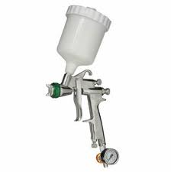  Trigger  Air cap  Fan adjuster valve  Volume control screw  Pressure adjuster valve  Pressure gauge  3 marks each | 18 | AC2.1
2 | Emery cloth  Compressor  Paint  Extraction  Breathing equipment  Masking tape  Masking paper  Spray gun  (or any other suitable answer)  4 marks each | 32 | AC3.1
 | Total | 50

